# **HW Assignment 4 Chong Chen NUID: 002833267**

### **Step 1**

### **1. Create the VPC**

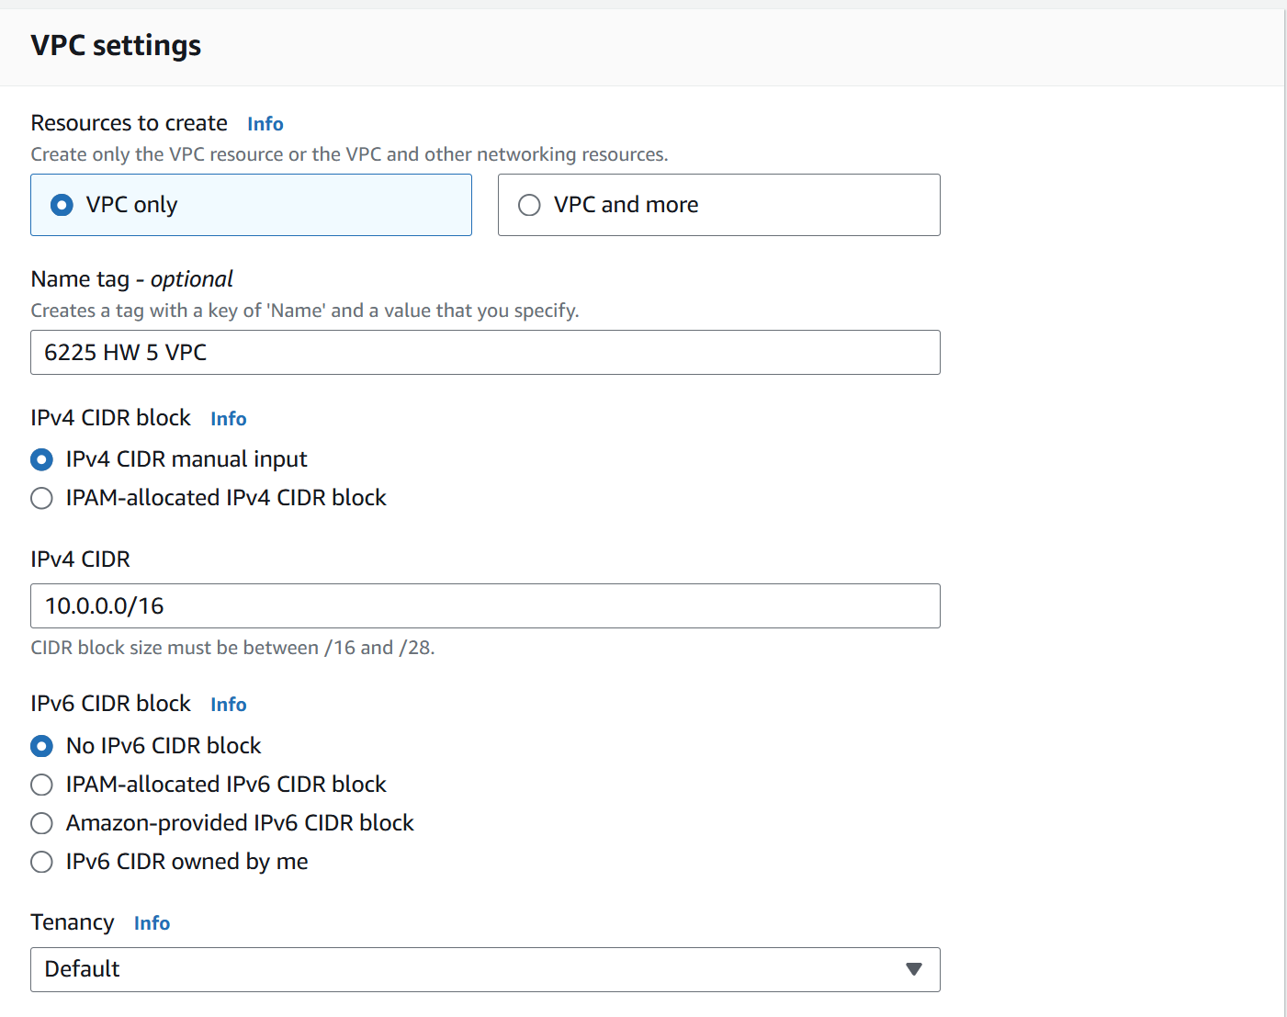

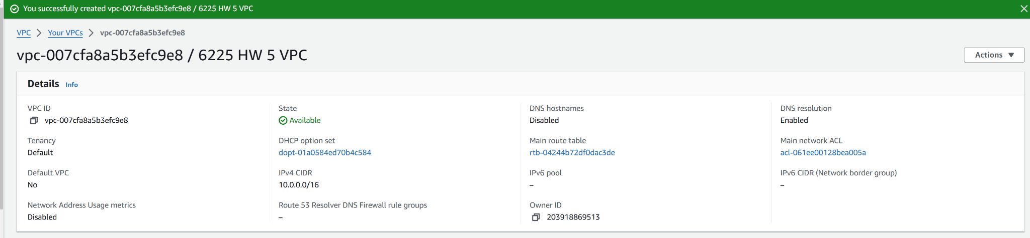

### **2. Create Subnets**

#### **Public Subnet 1**

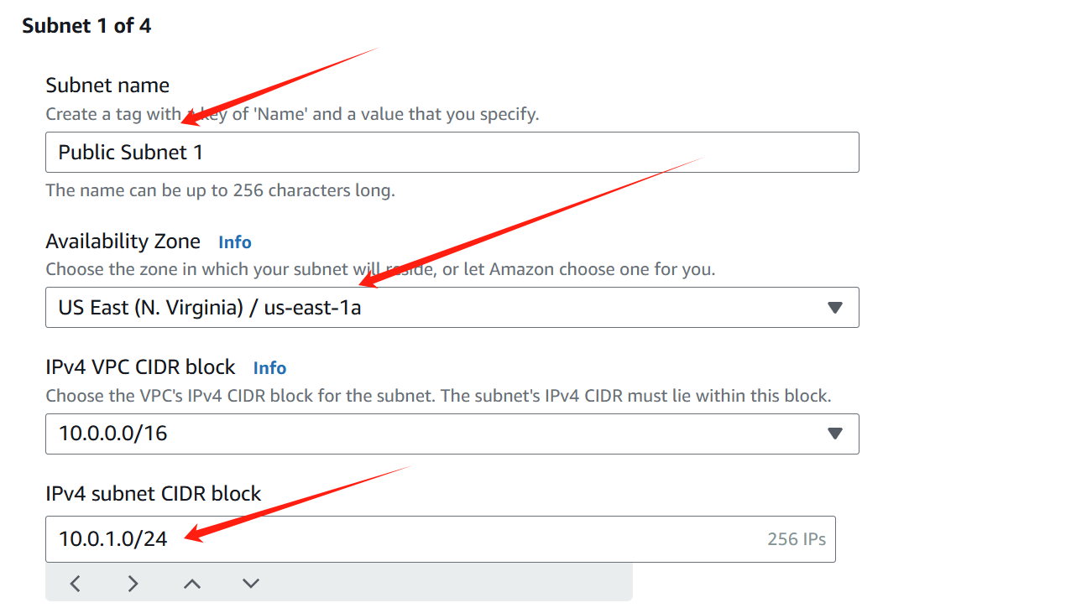

#### **Public Subnet 2**

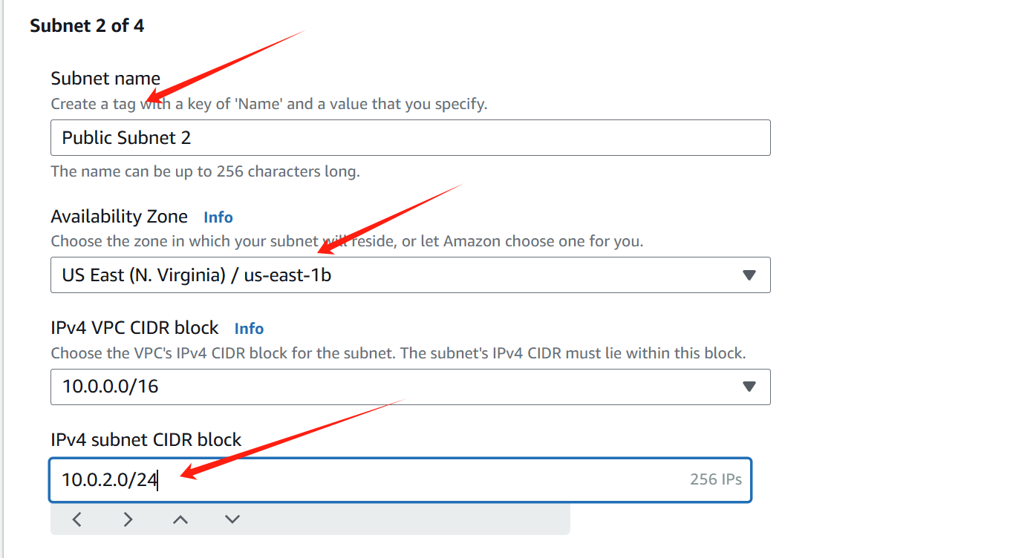

#### **Private Subnet 1**

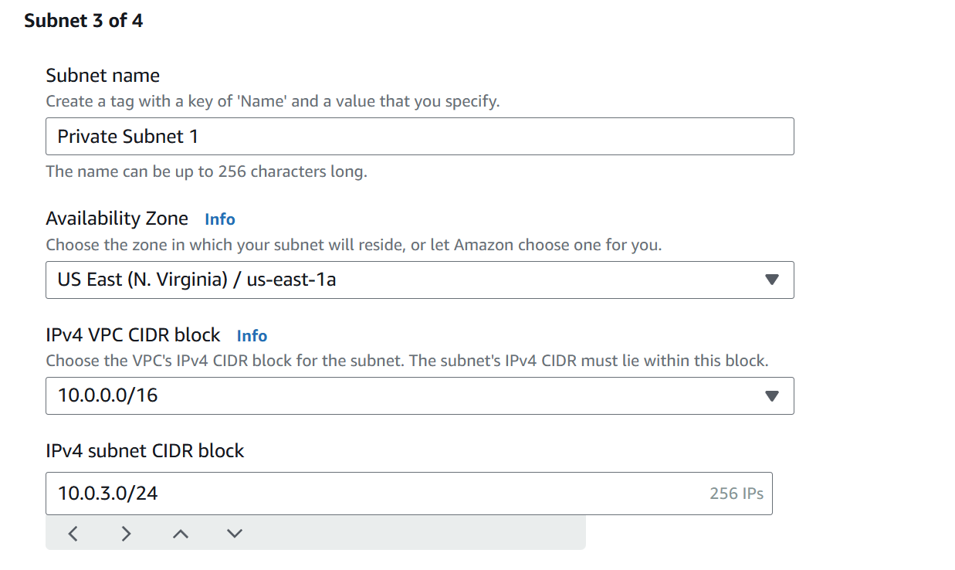

**Private Subnet 2**

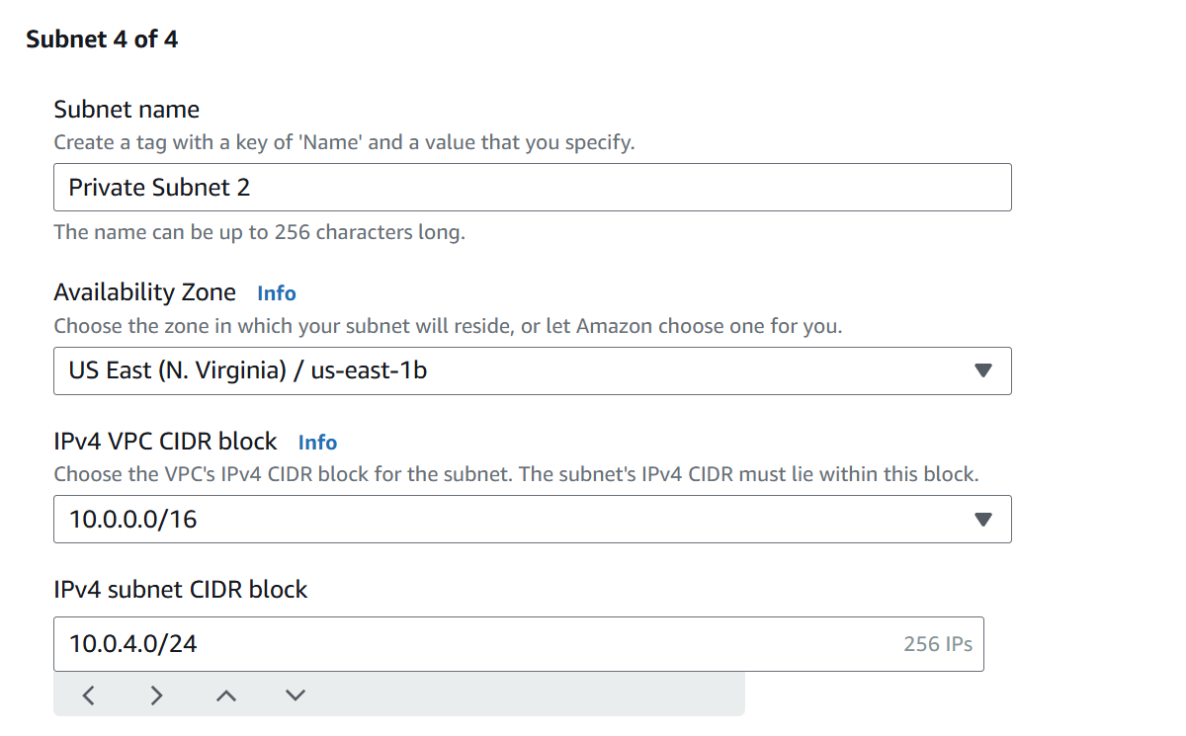

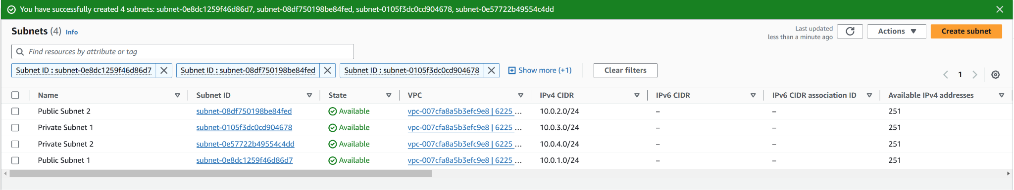

### **3. Create an Internet Gateway**

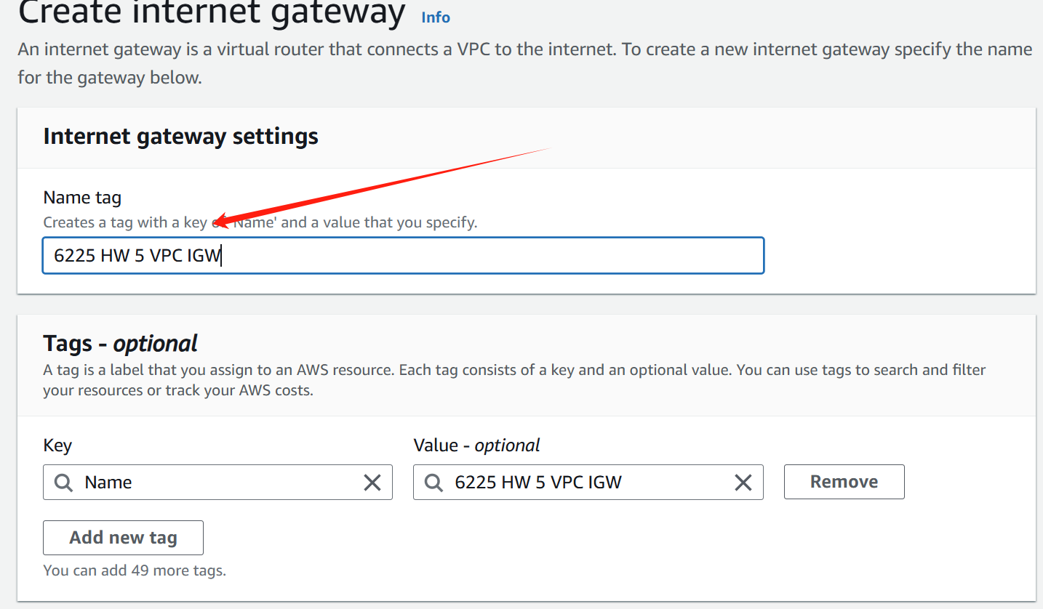

Attach Internet Gateway to **6225 HW 5 VPC**

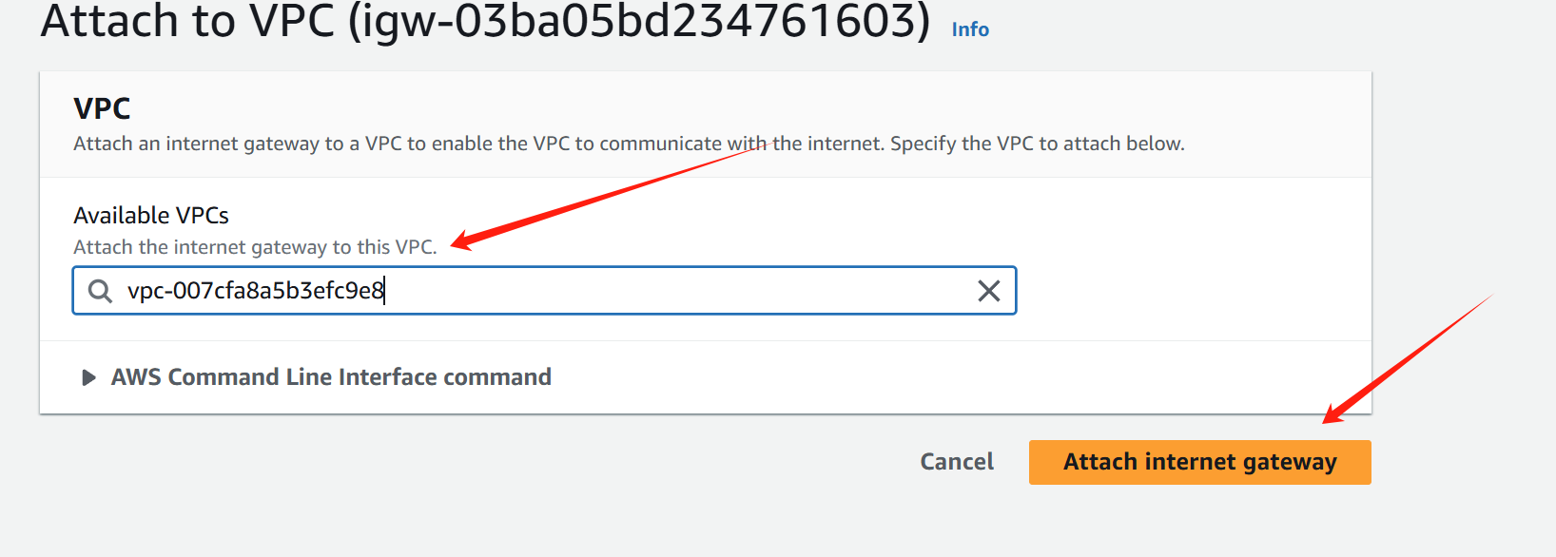

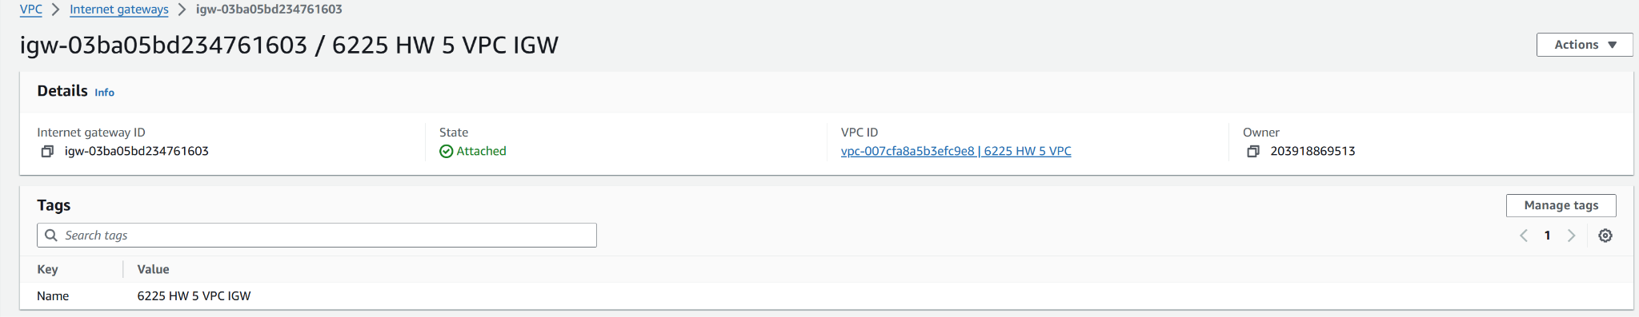

### **4. Set Up Route Tables**

#### **Public Subnet Route Table**

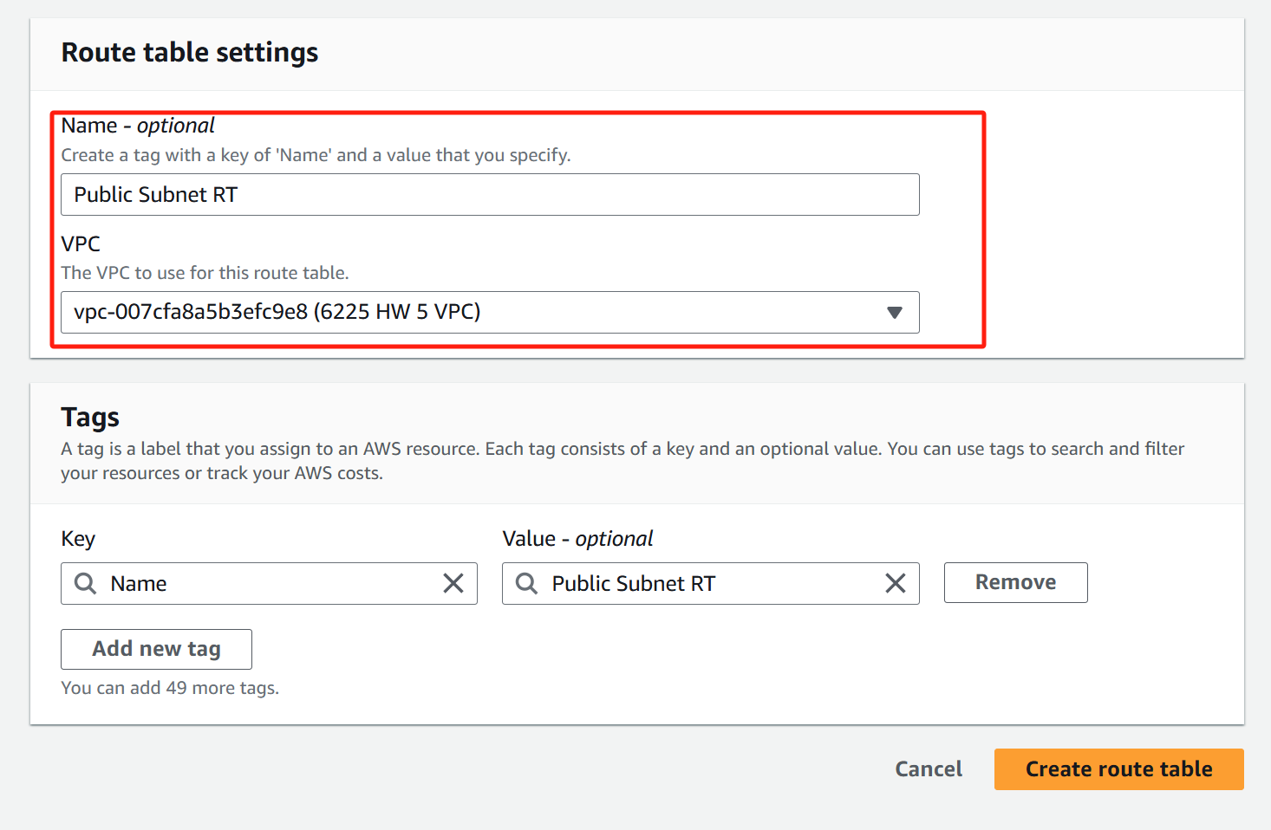

**Edit routes** and add Destination: 0.0.0.0/0 and Target.

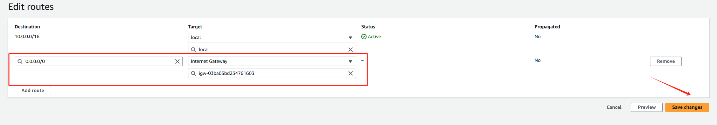

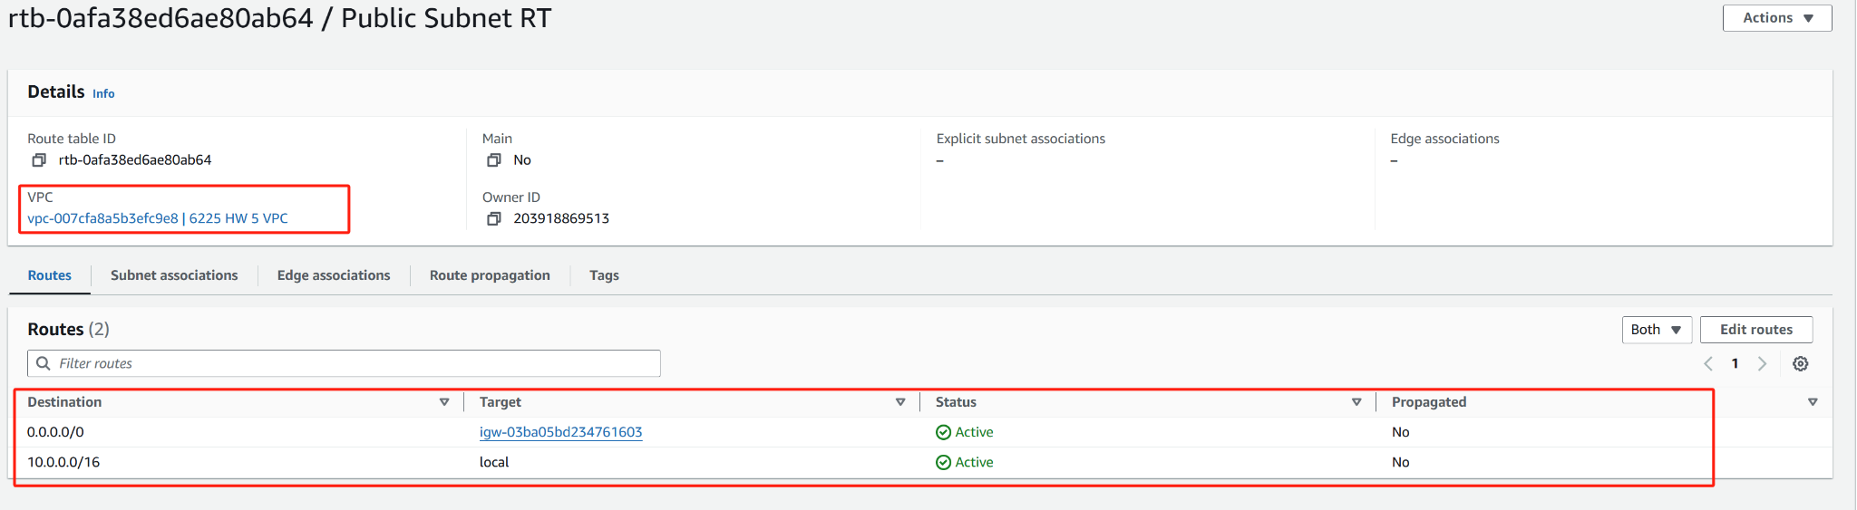

**Edit subnet associations:**

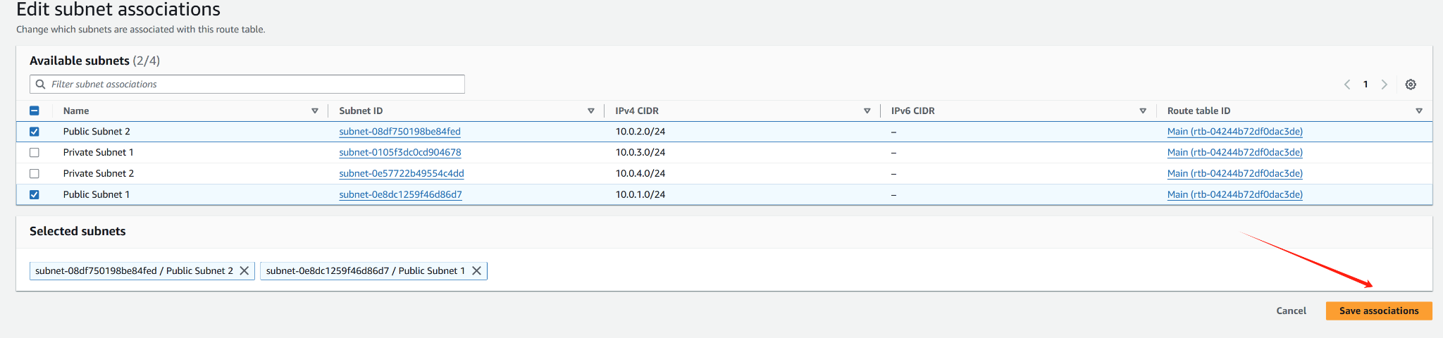

**Associate it with Public Subnet 1 and Public Subnet 2**

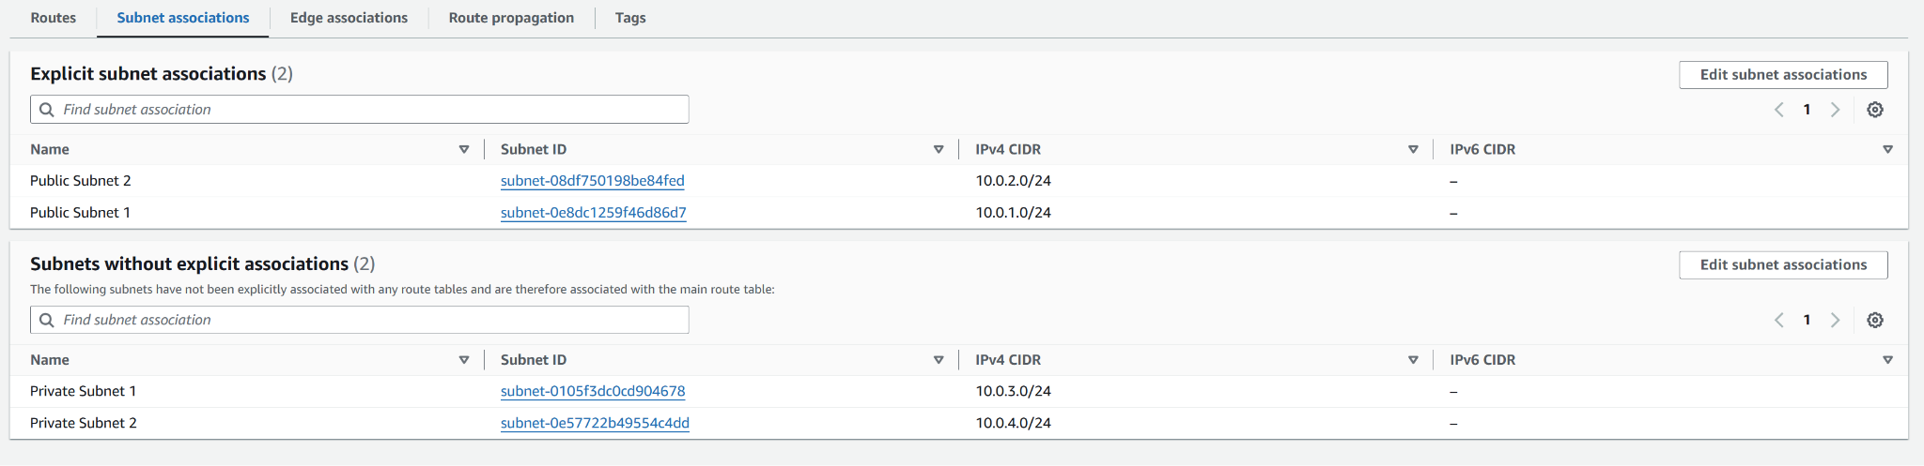

#### **Private Subnet Route Table**

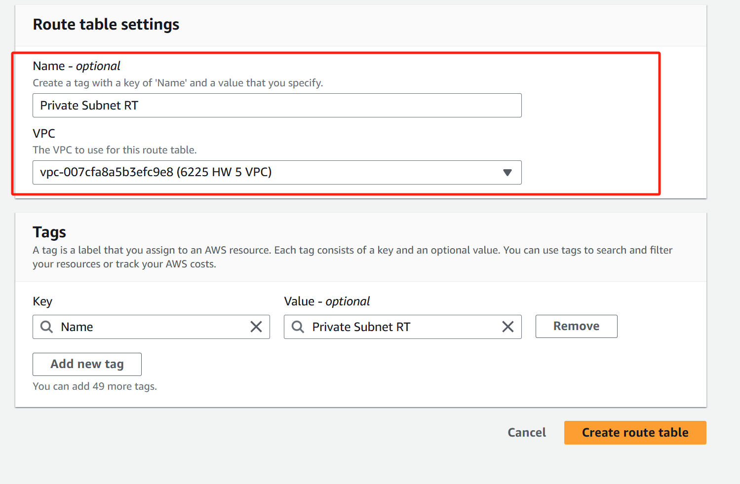

**Edit subnet associations**

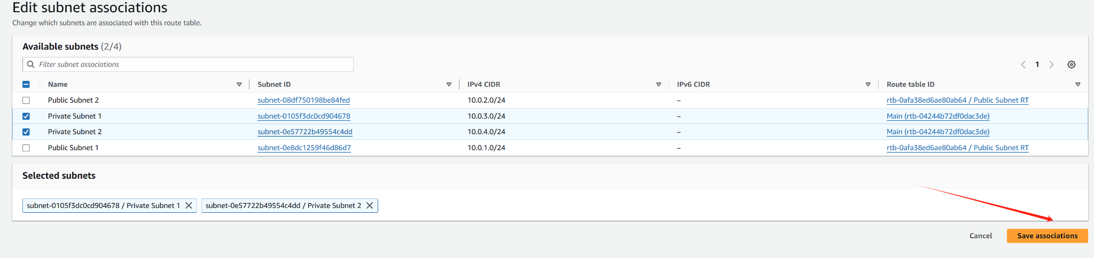



**Associate it with Private Subnet 1 and Private Subnet 2**

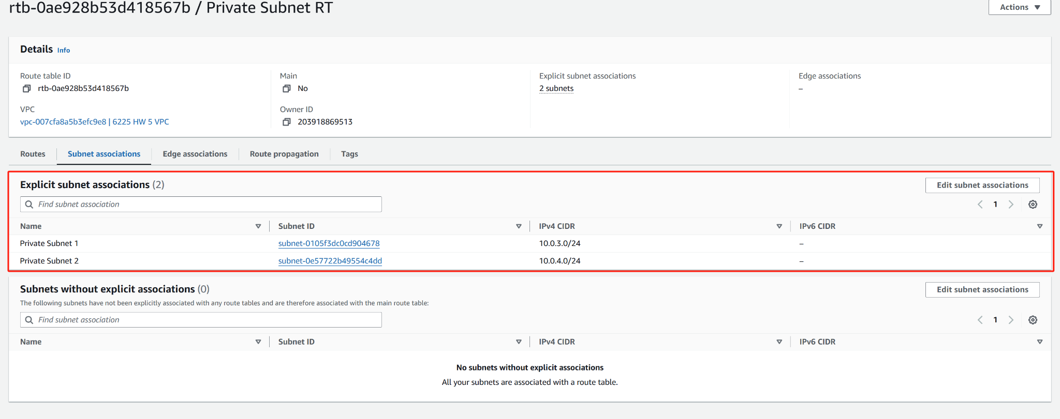

### **Step 2**

### **1. Create an S3 Bucket**

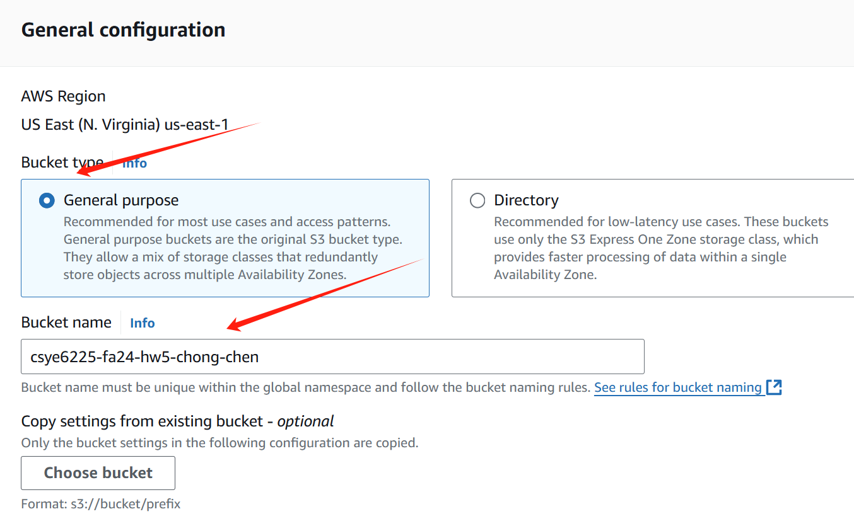

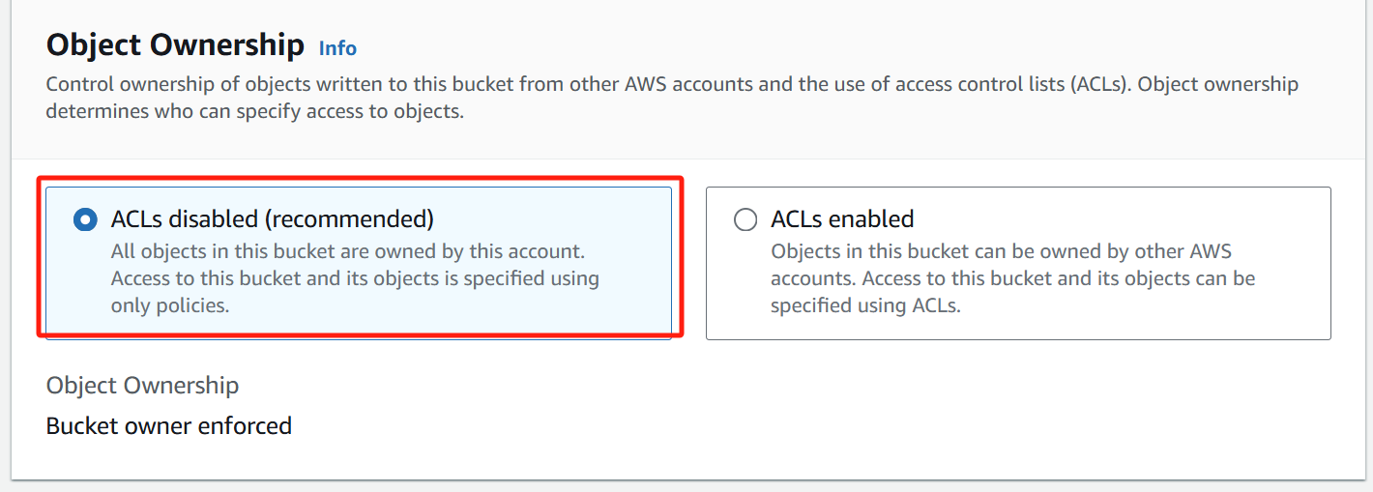

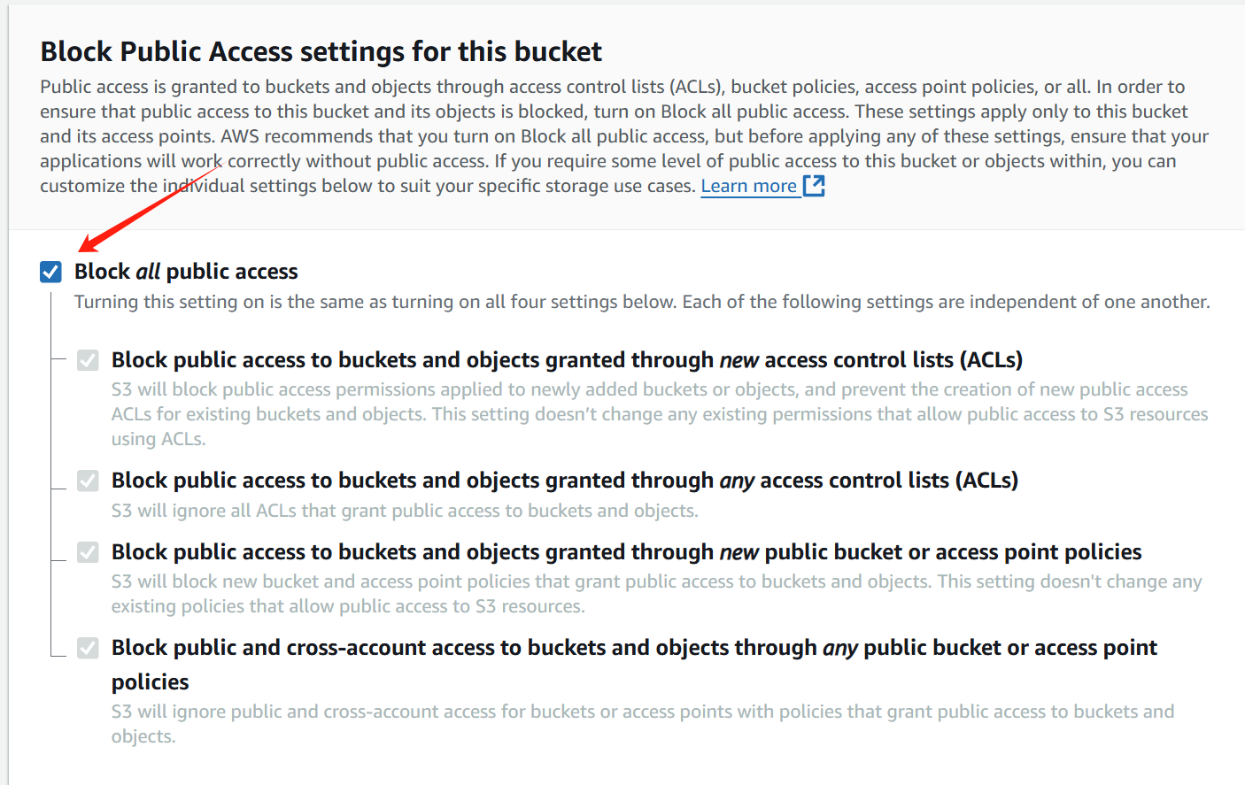

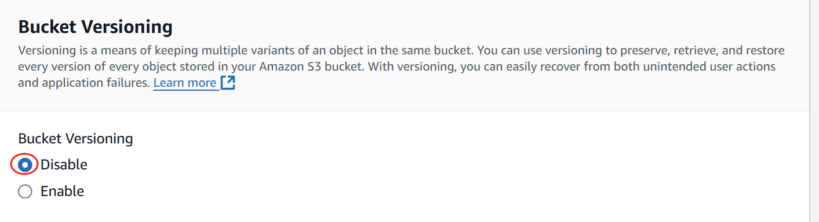

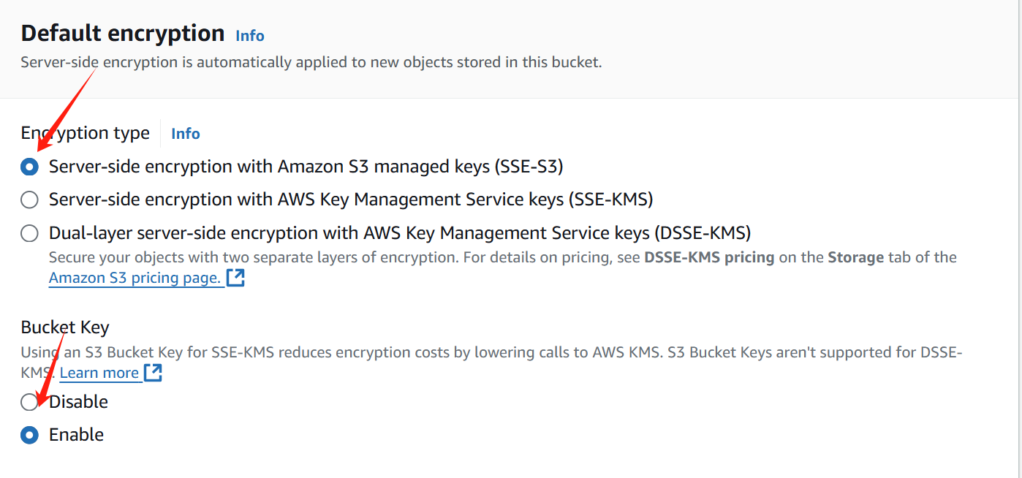

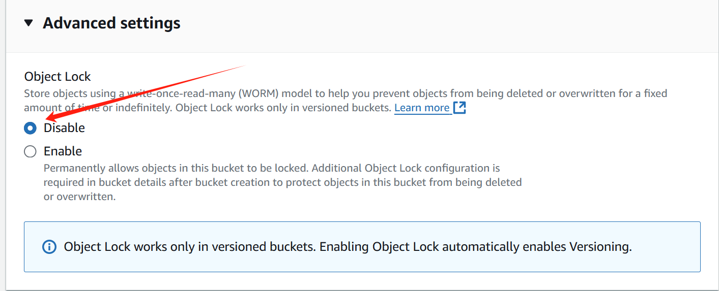

**Leave other settings as default and choose Create bucket**

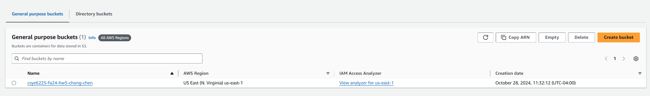

**2. Enable Public Access**

**Disable Block Public Access**

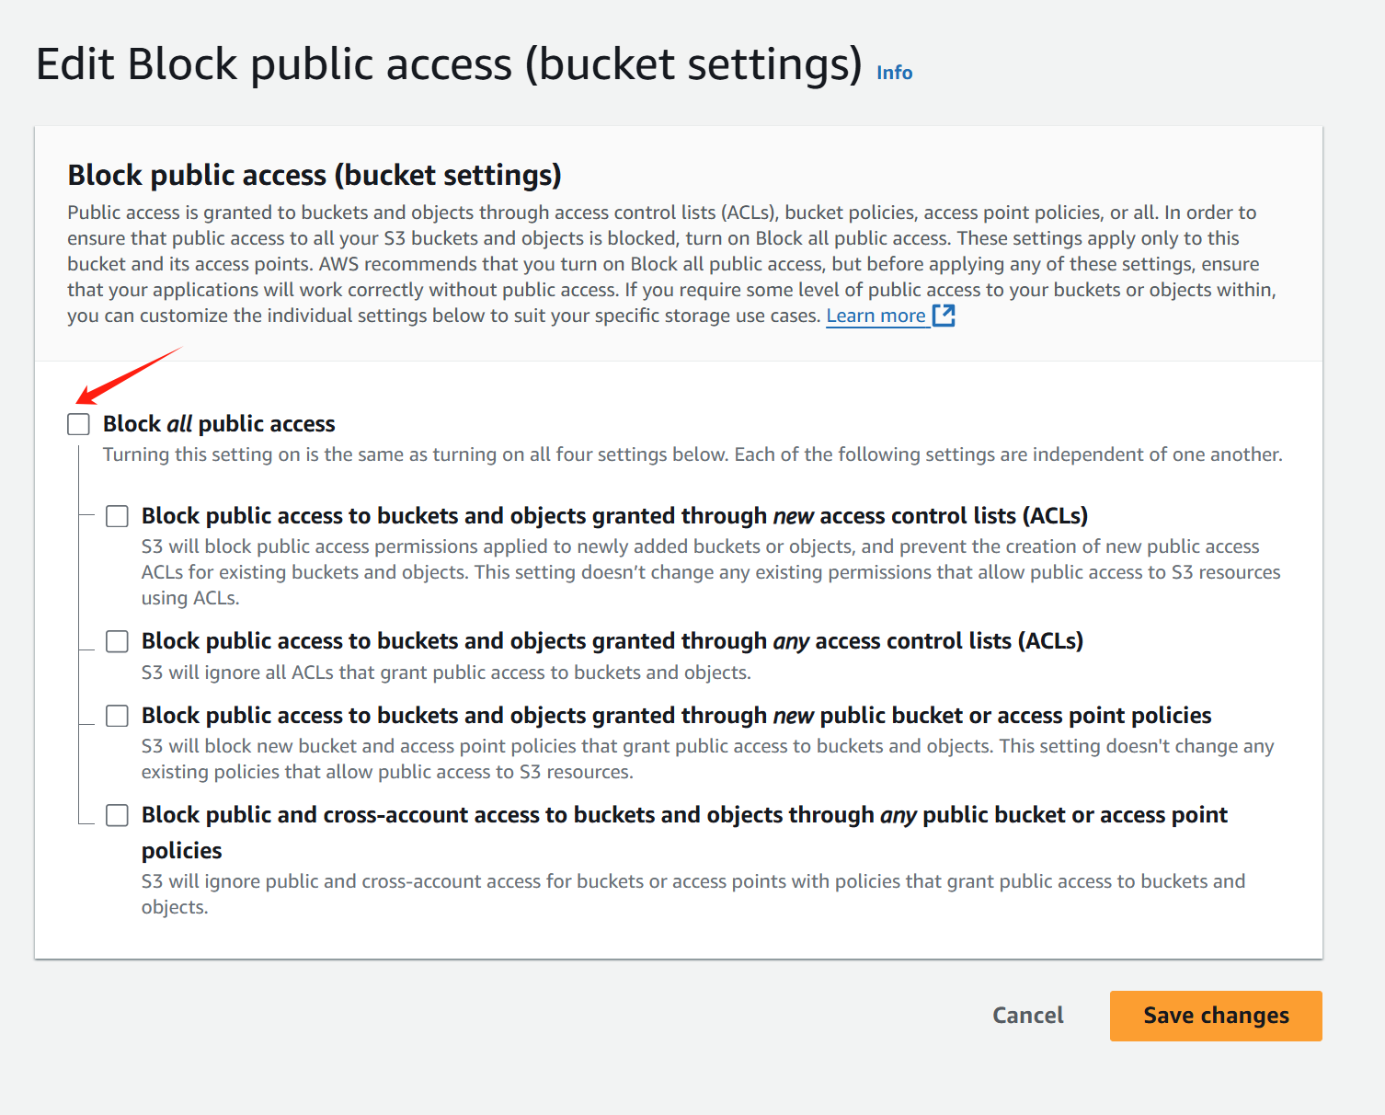

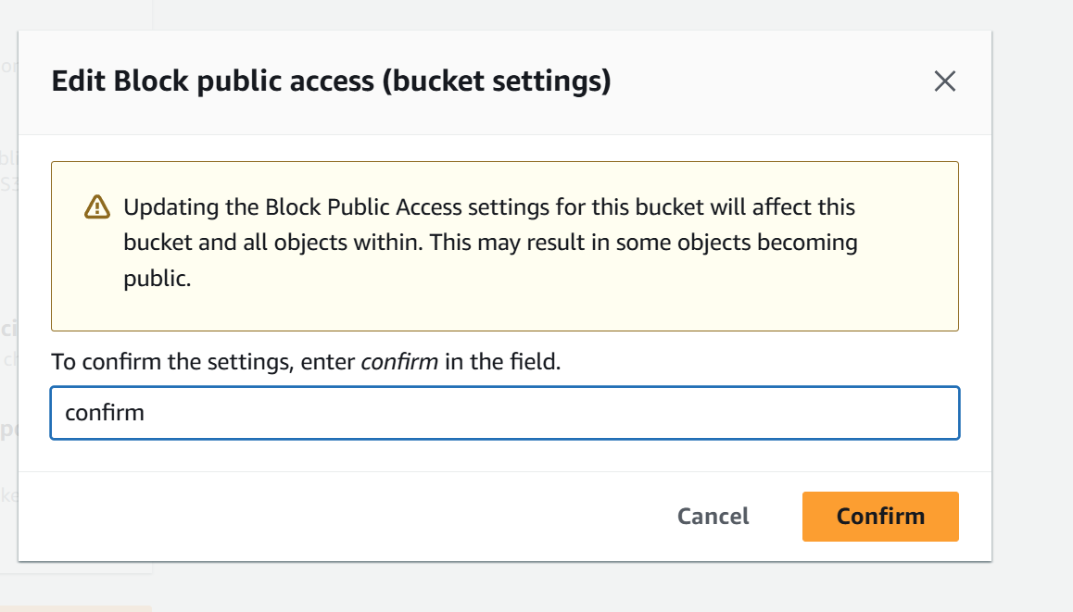

#### 

#### **Update the Bucket Policy**

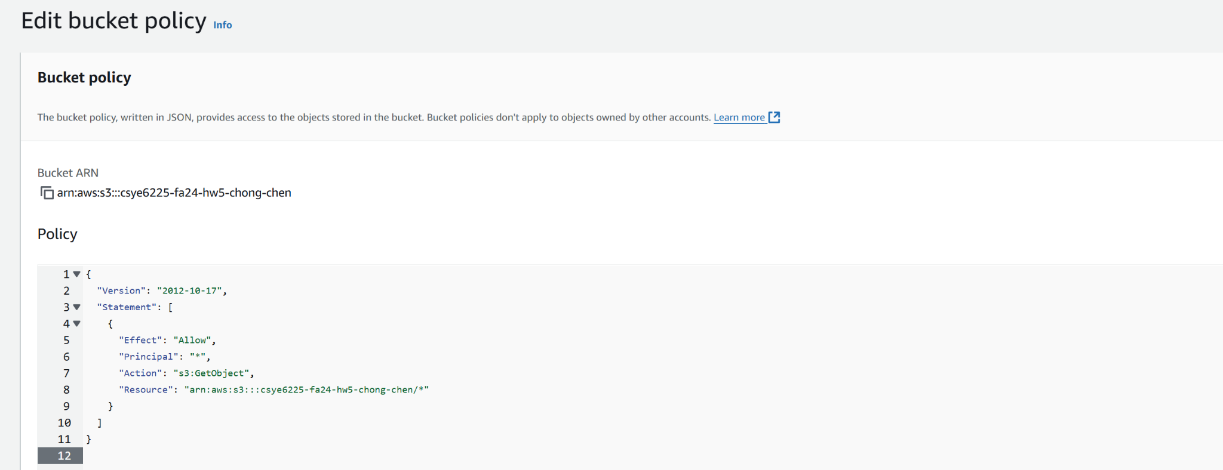

**3. Upload a File to the Bucket**

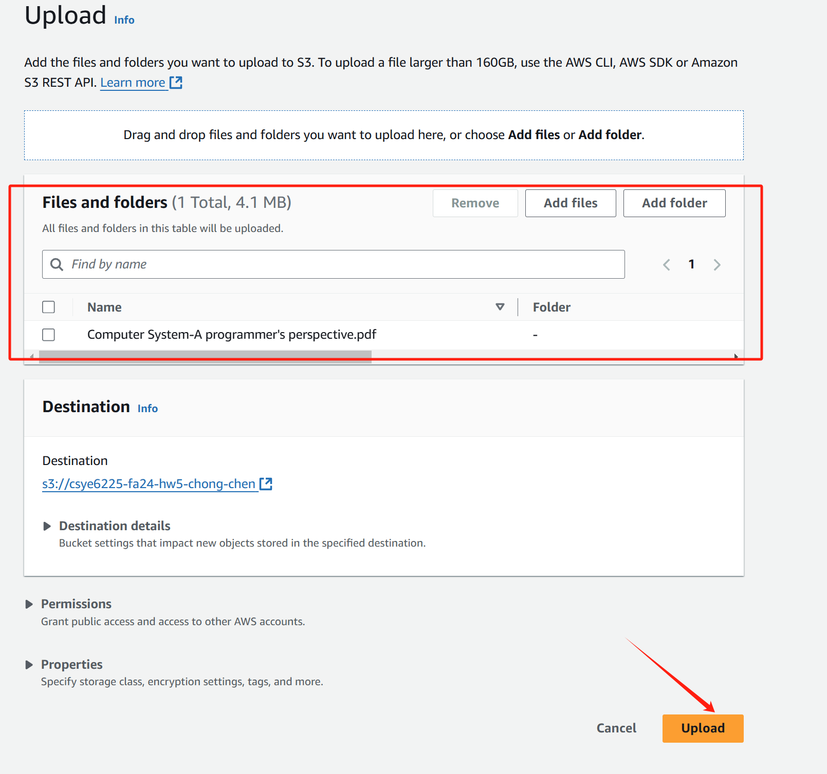

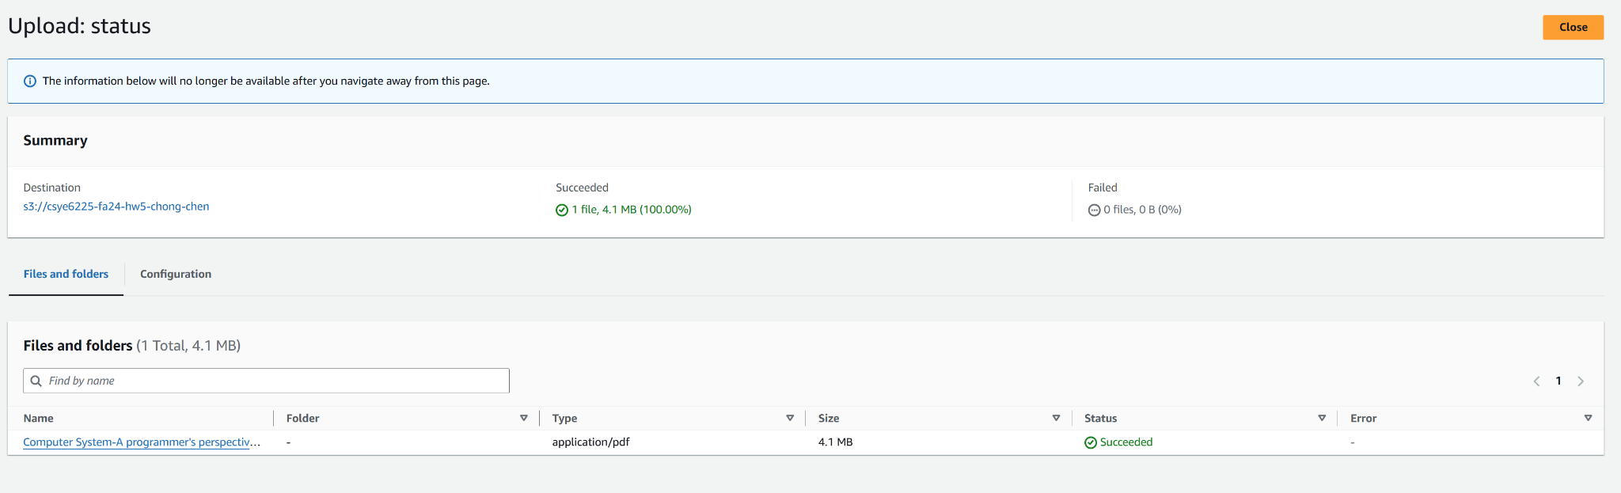

**4. Create a Folder and Upload a File**

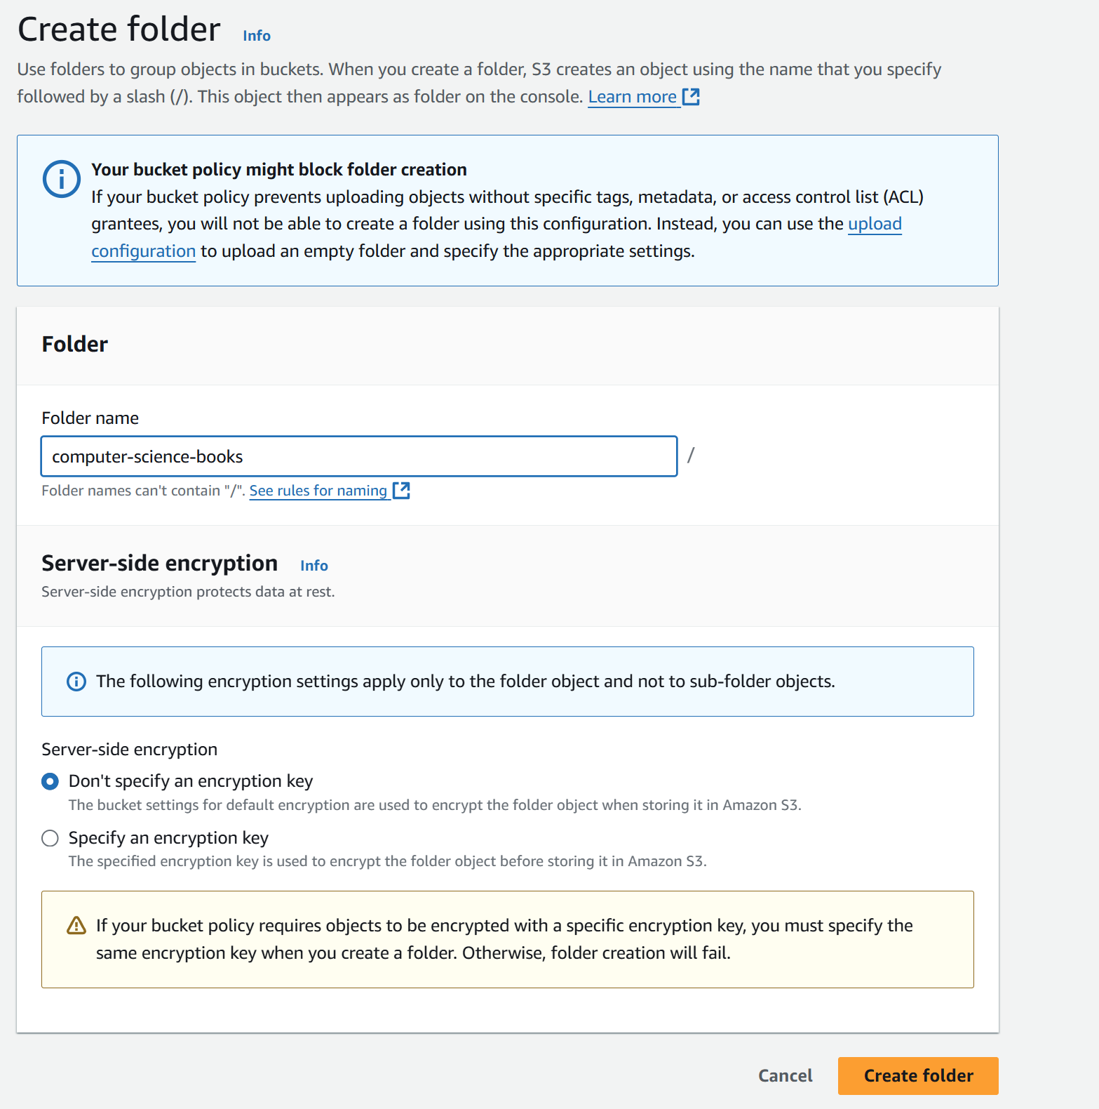

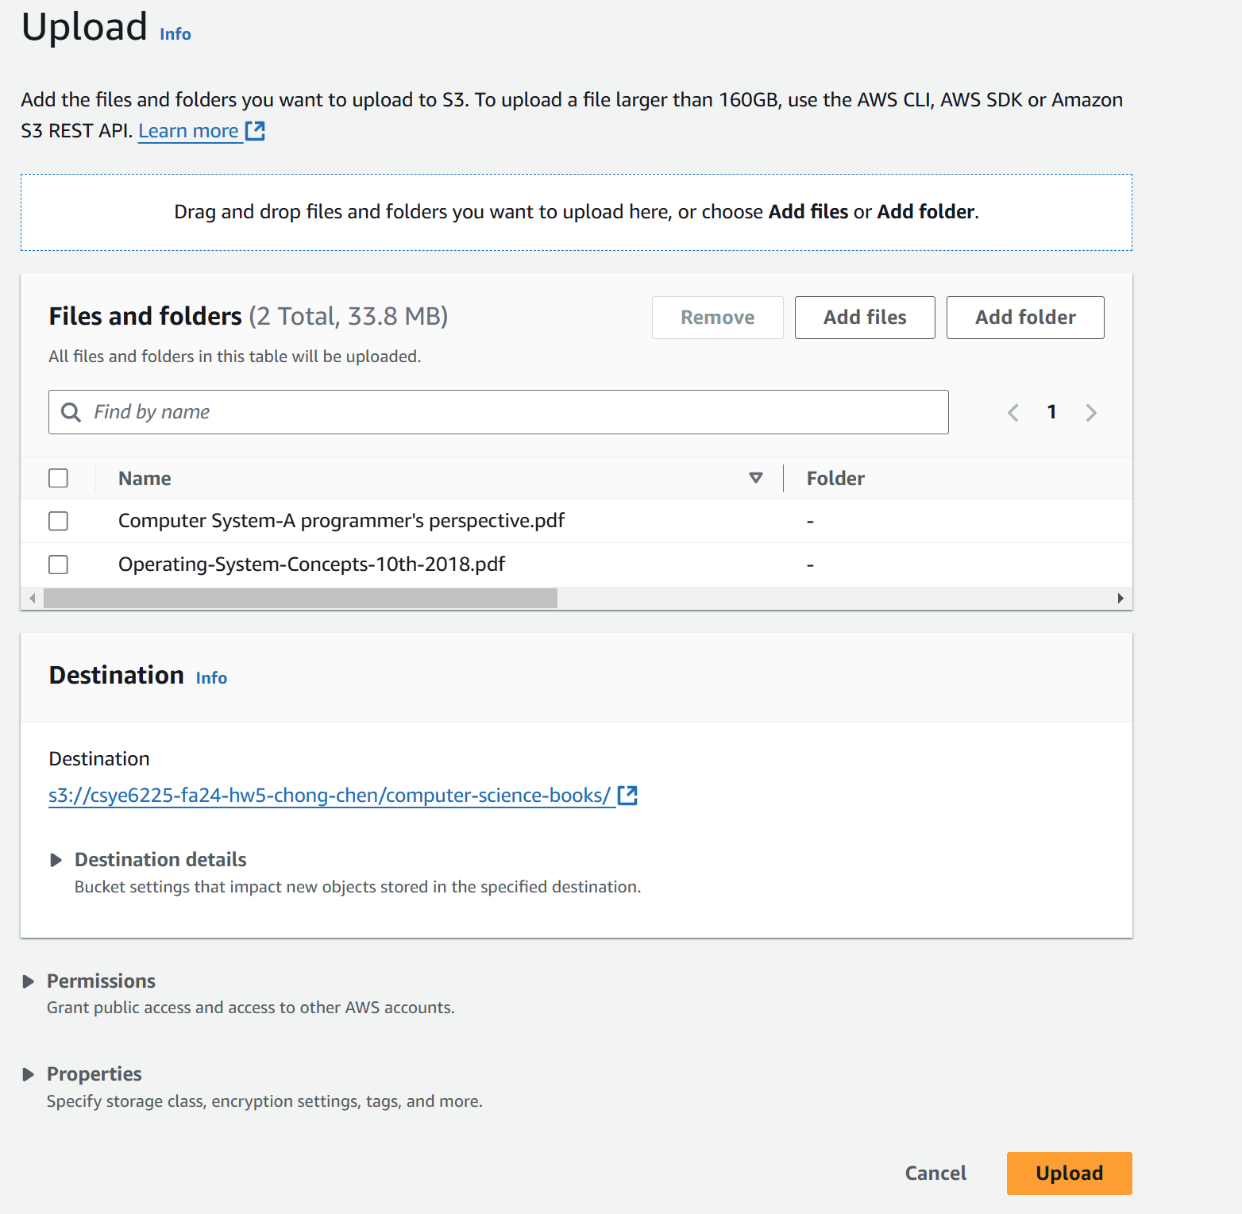

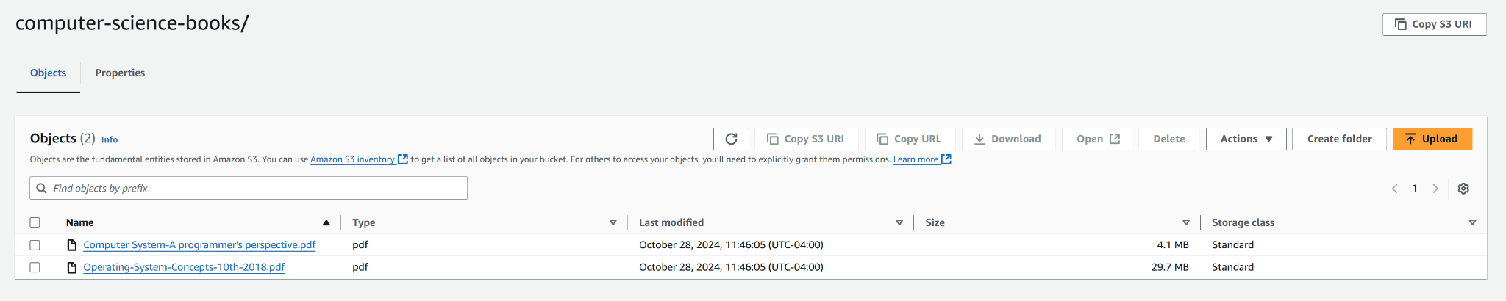

### 

### **5. Access an Object via URL**

**Under Object URL, copy the URL link provided**

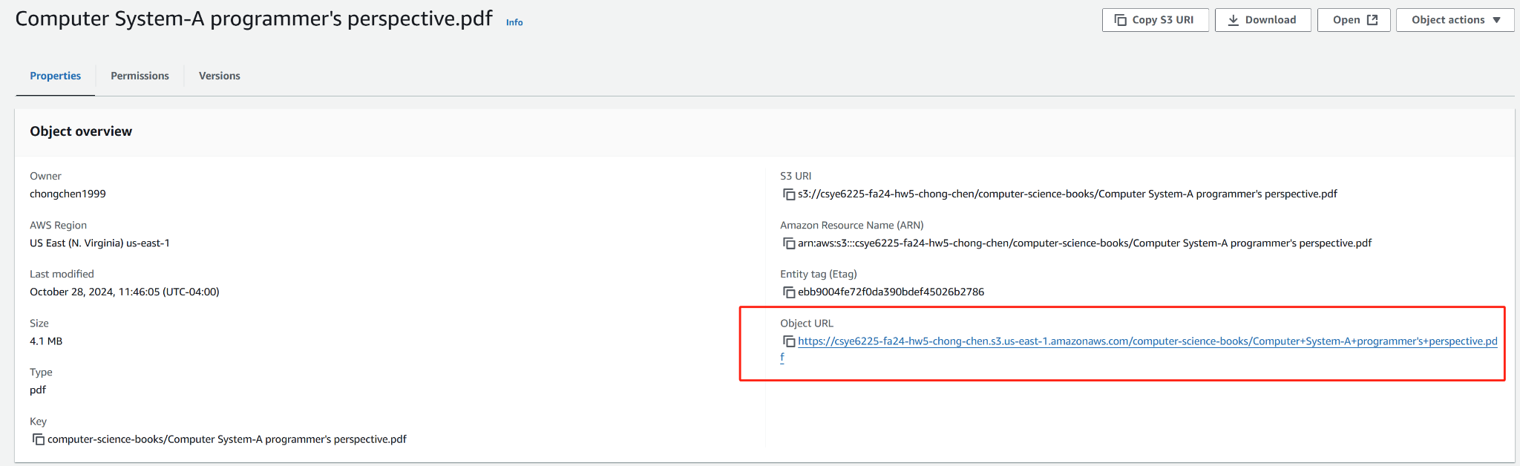

**Paste the URL into your browser to verify public access**

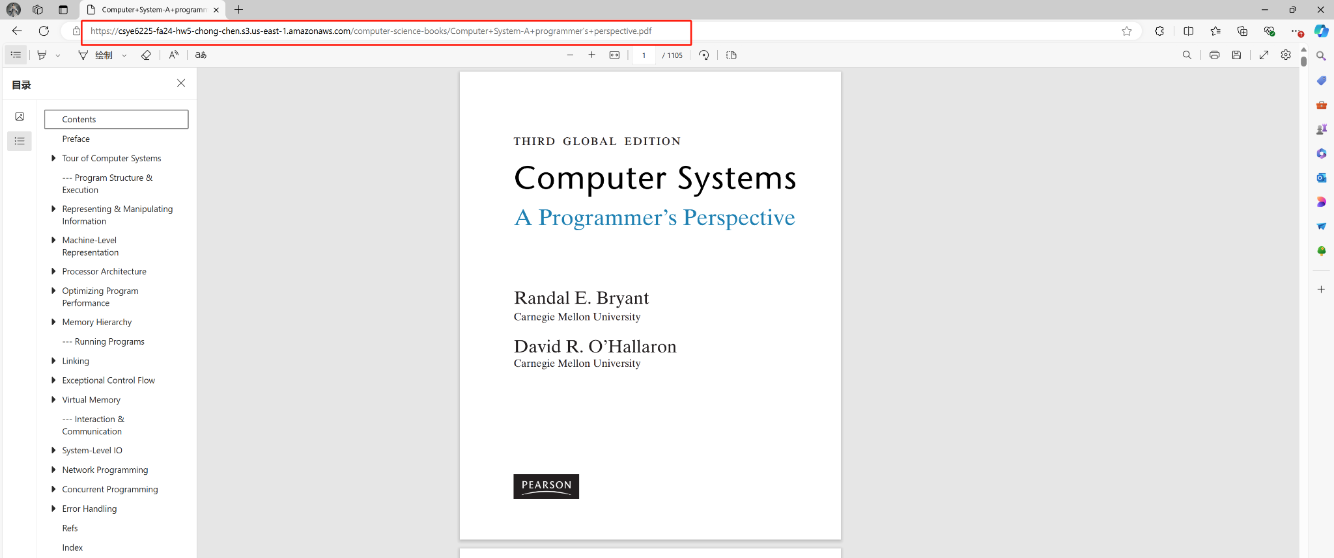

### 

### 

### 

### 

### 

### 

### **Step 3**

**1. Create an EC2 Instance in Public Subnet 1**

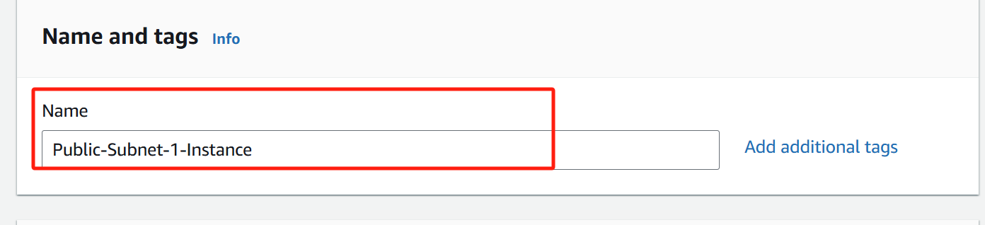

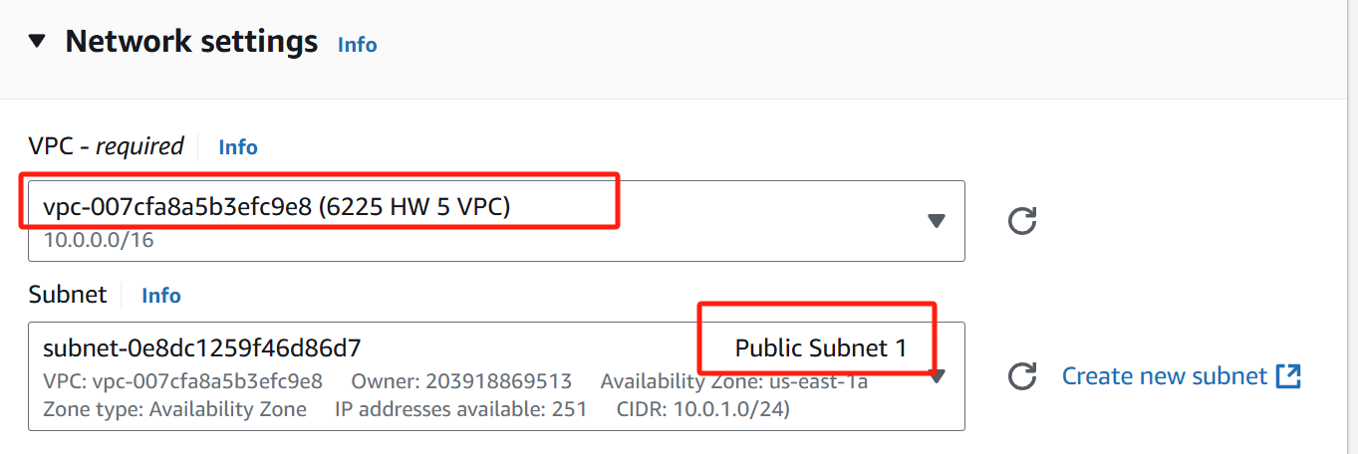**2. Select Ubuntu as the OS Image**

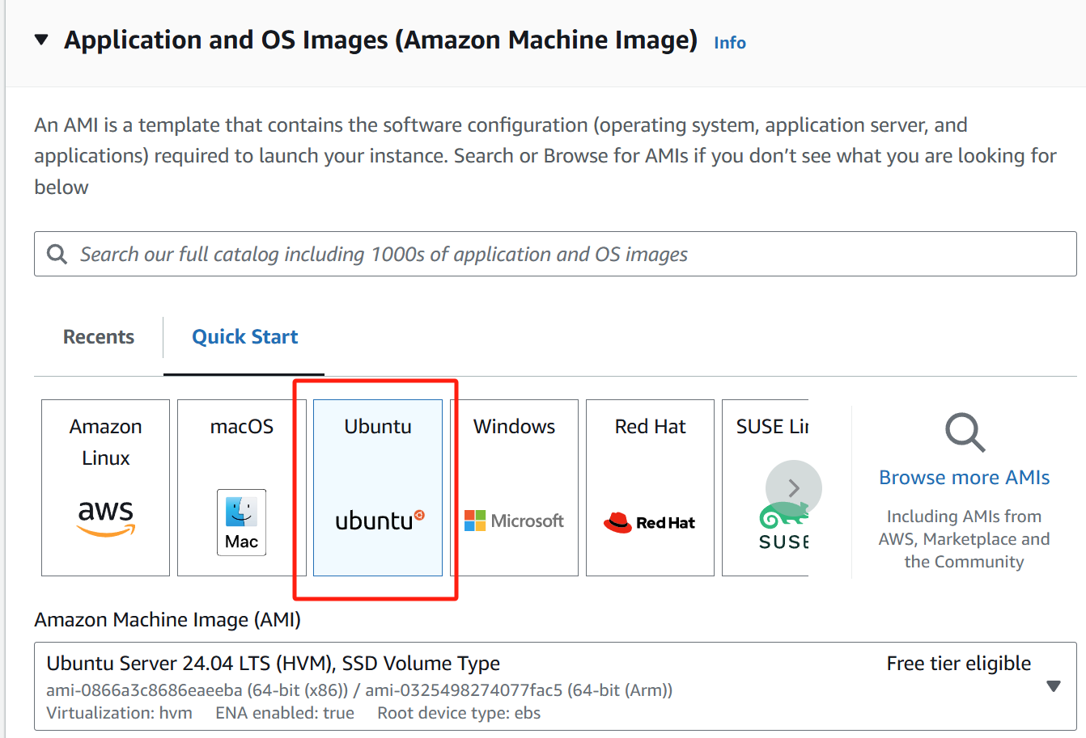

### 

### **3. Select Key-Pairs for Login**

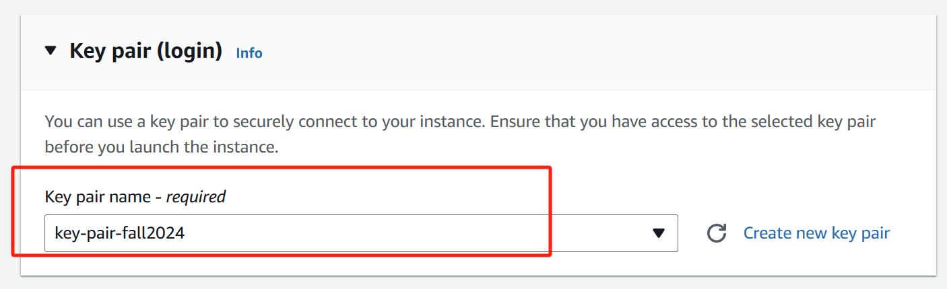

### **4. Enable Auto-assign Public IP**

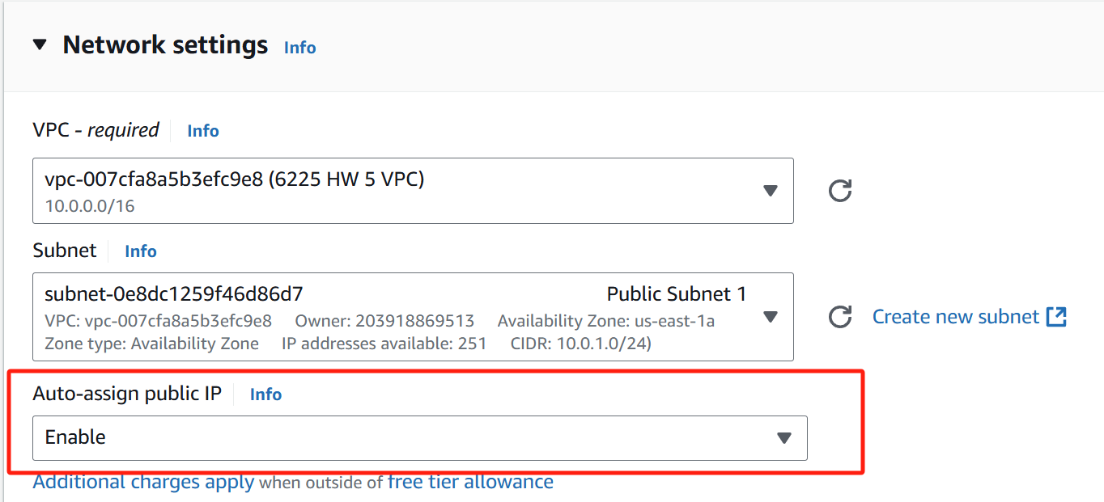

### 

### 

### 

### 

### 

### 

### 

### **5. Select or Create a Security Group for SSH Access**

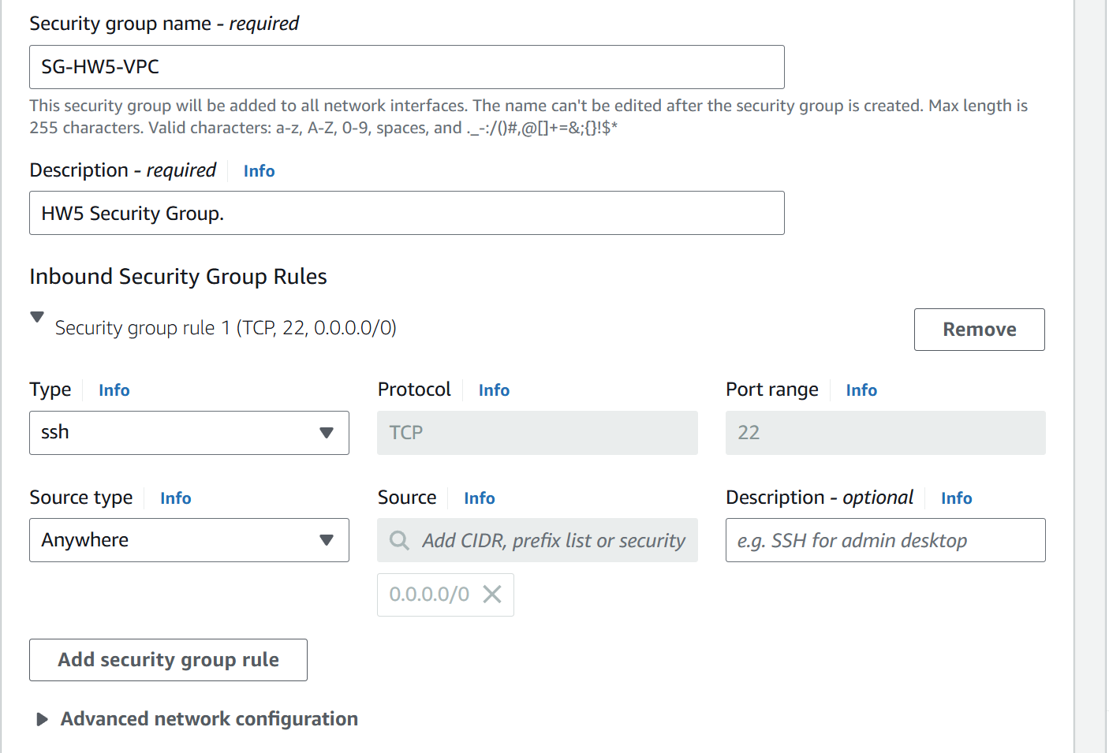



### 

### 

### 

### 

### 

### 

### 

### **Step 4**

### **1. SSH into Your EC2 Instance**

### 

### 

### 

### 

### **2. Use wget to Download the Object from S3**



### **3. List the Directory with ls**

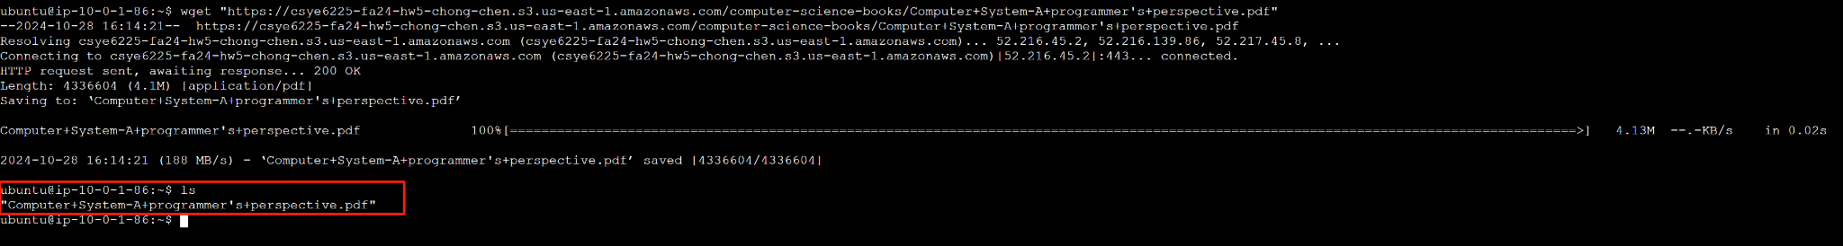

### **4. Does the Network Call Go Through the Internet or AWS Network?**

Since the EC2 instance is in a public subnet and has a public IP, the wget command downloads the S3 object **through the Internet**. This occurs because the EC2 instance accesses the public S3 endpoint (*https://csye6225-fa24-hw5-chong-chen.s3.us-east-1.amazonaws.com*) over an internet connection rather than through an internal VPC endpoint.

### 

### 

### 

### 

### 

### 

### 

### 

### 

### 

### **Step 5**

### **1. Navigate to VPC Endpoints**

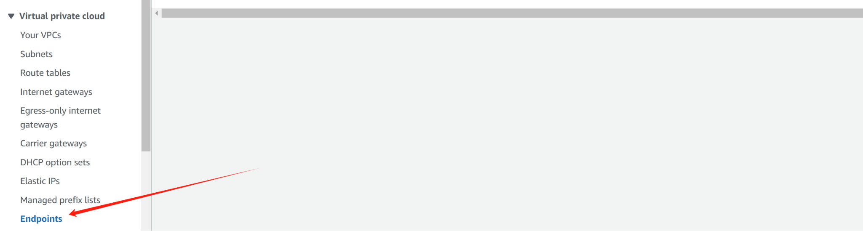

### **2. Create the S3 Gateway Endpoint**

Select **AWS services**

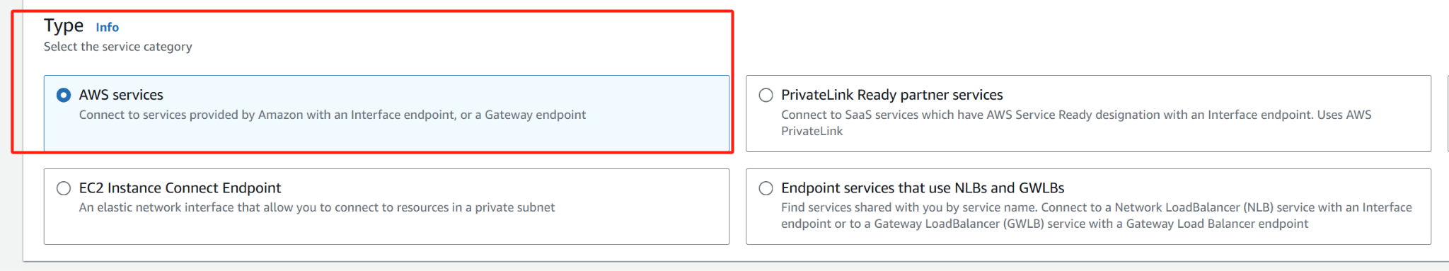

**Type = Gateway** and select **com.amazonaws.us-east-1.s3**

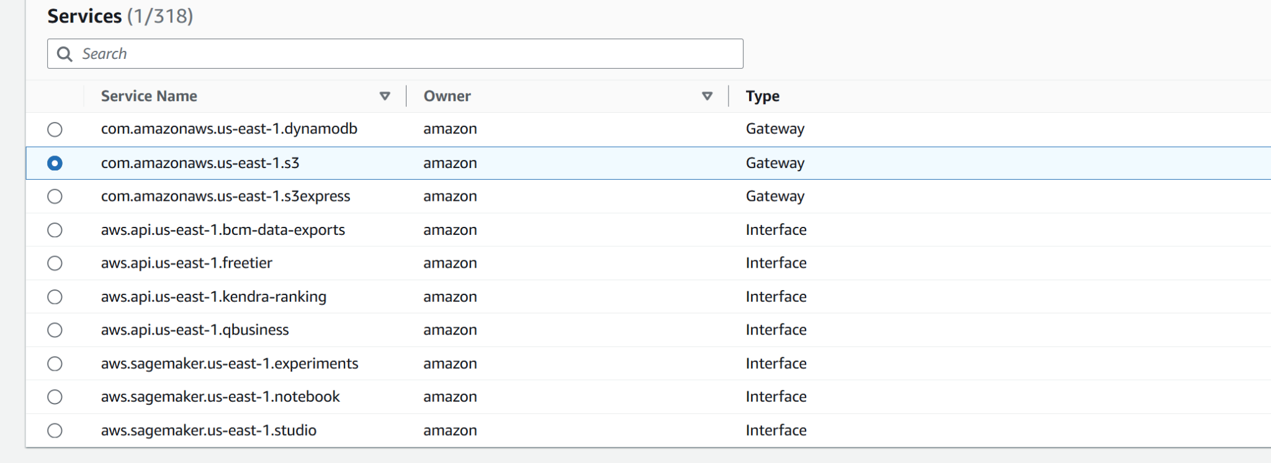

**Select the VPC 6225 HW 5 VPC**

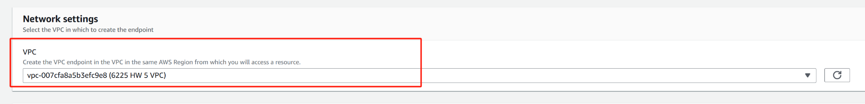

Associated with **Public Subnet RT**

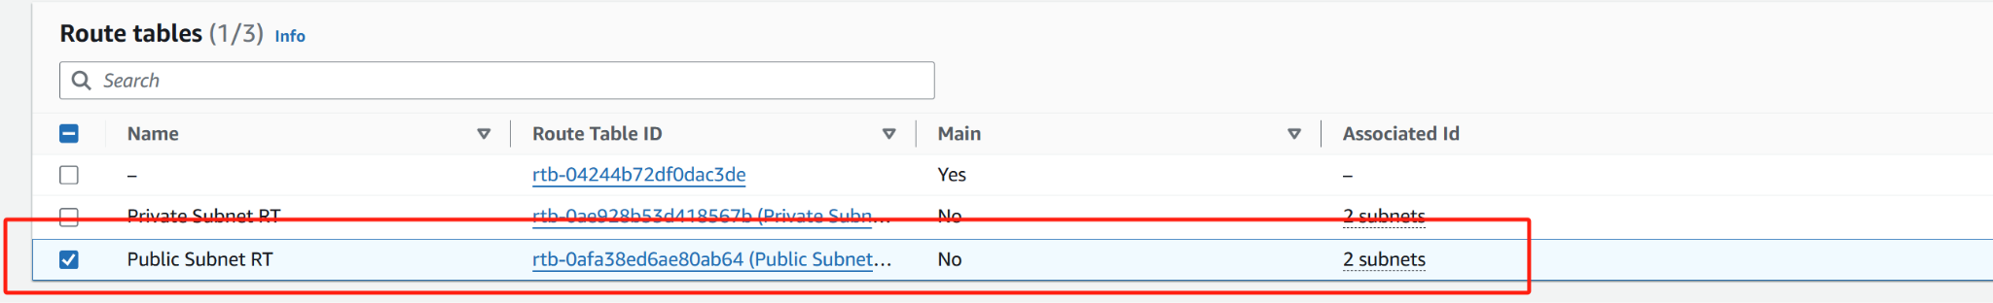

Choose **Full access**

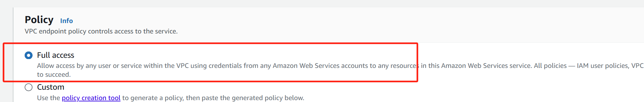



### **3. Verify the Route Table Entry**

Under the **Routes tables** tab

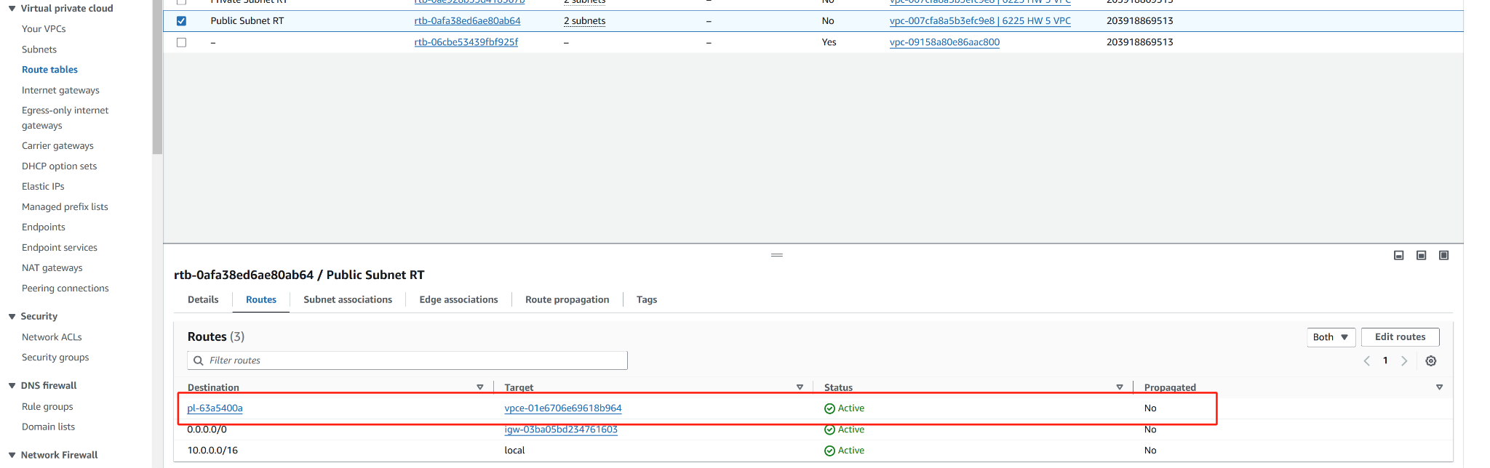

Under the **Subnets** tab

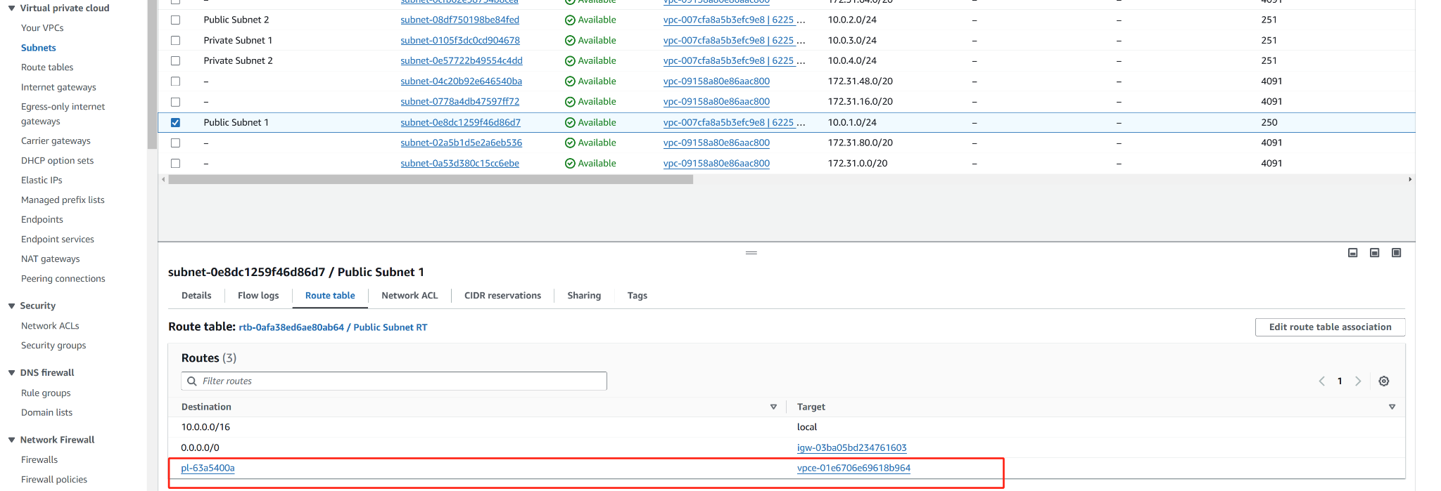

### 

### **Bonus step**

### **1. Set Up VPC Flow Logs**

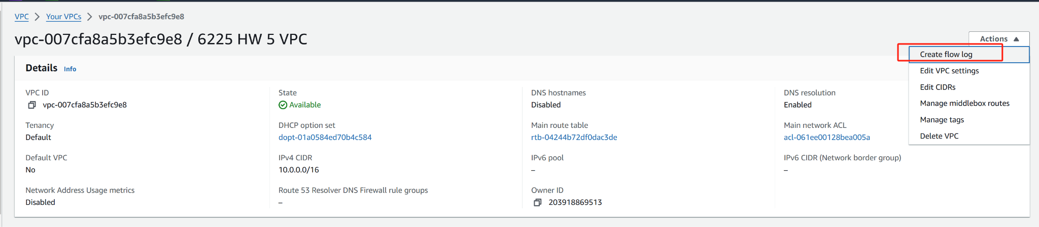

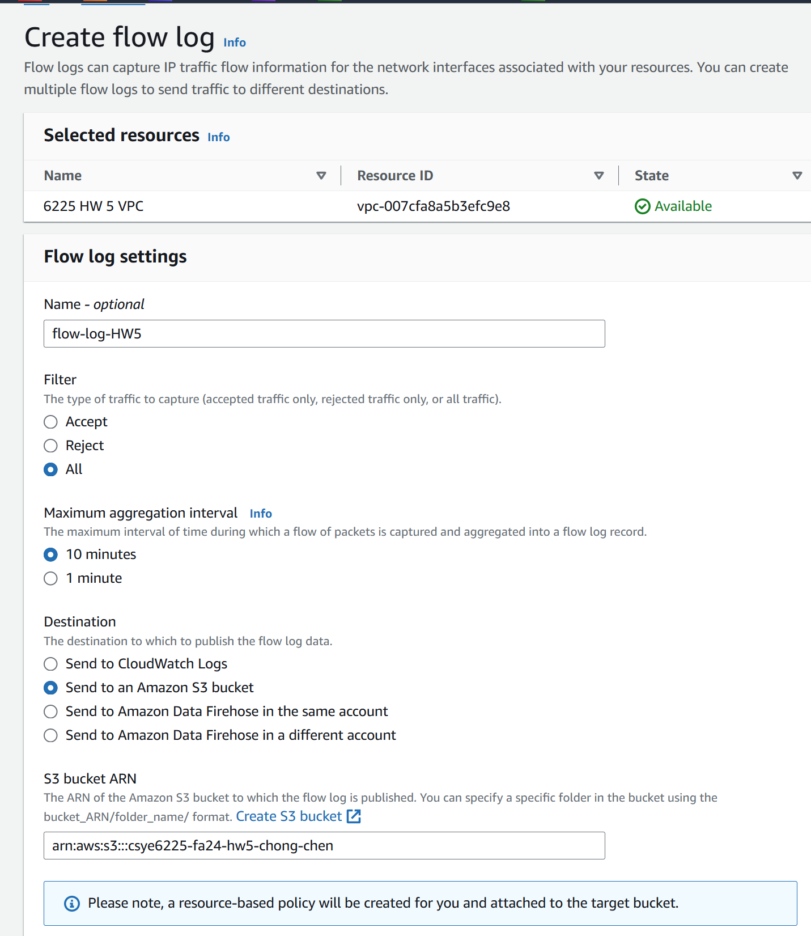

### **2. Install AWS CLI on the EC2 Instance**

**Run the following commands to install AWS CLI**

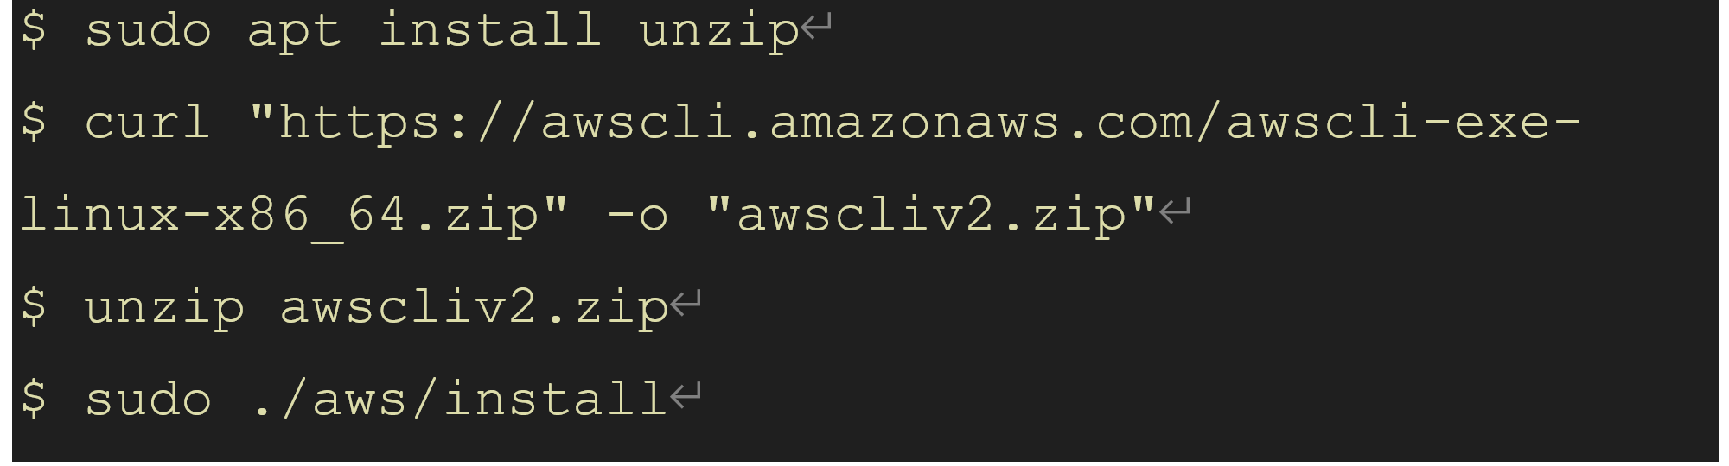

**Verify installation by running**



### **3. Configure AWS CLI Credentials on EC2**

**Create an Access Key**

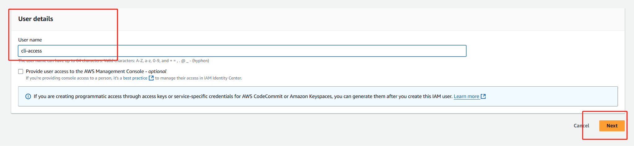

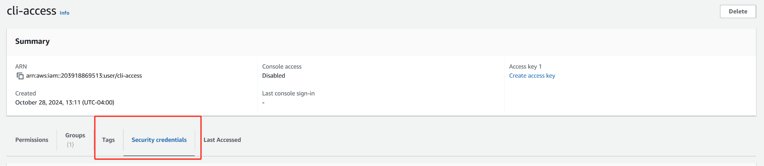

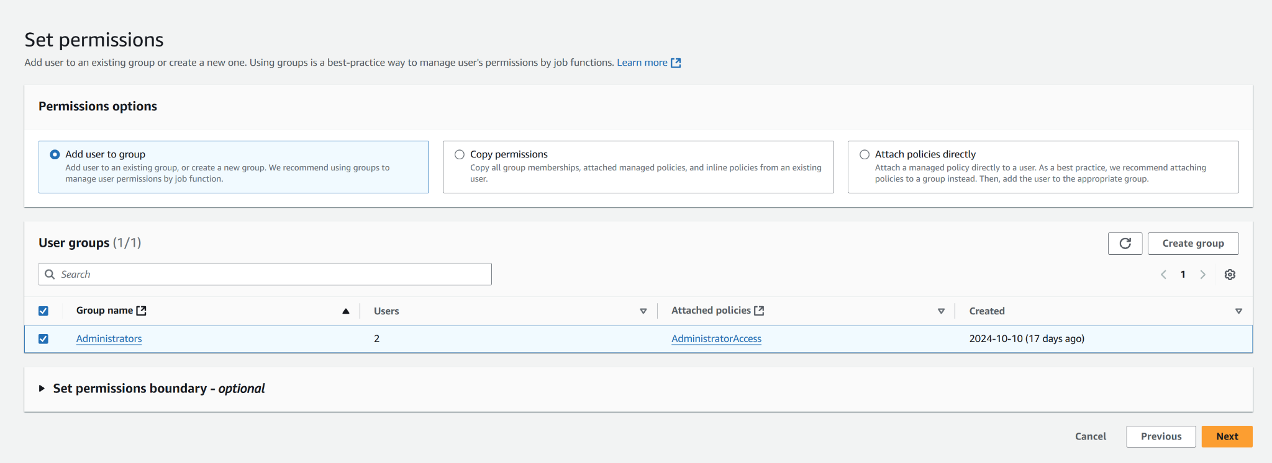

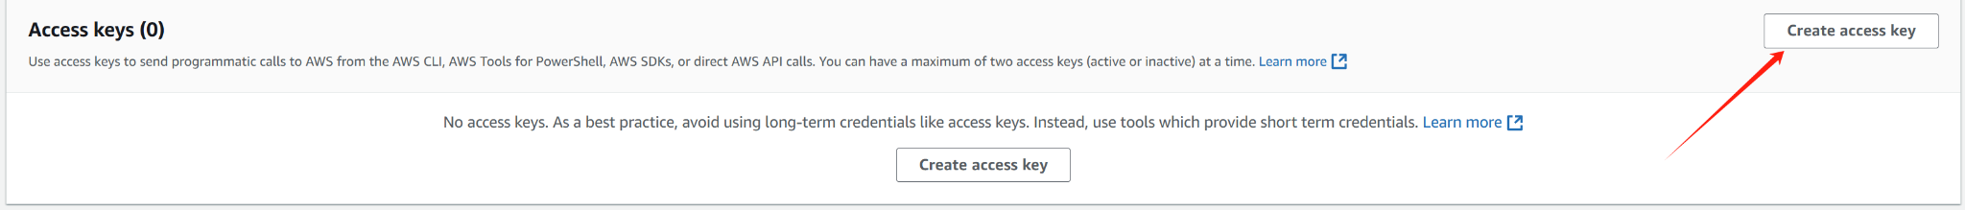

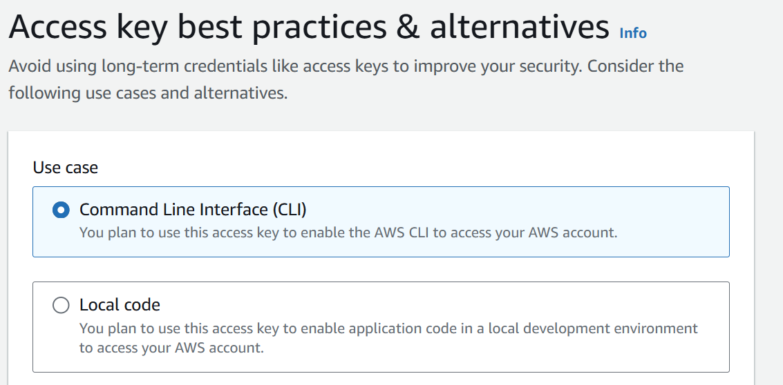

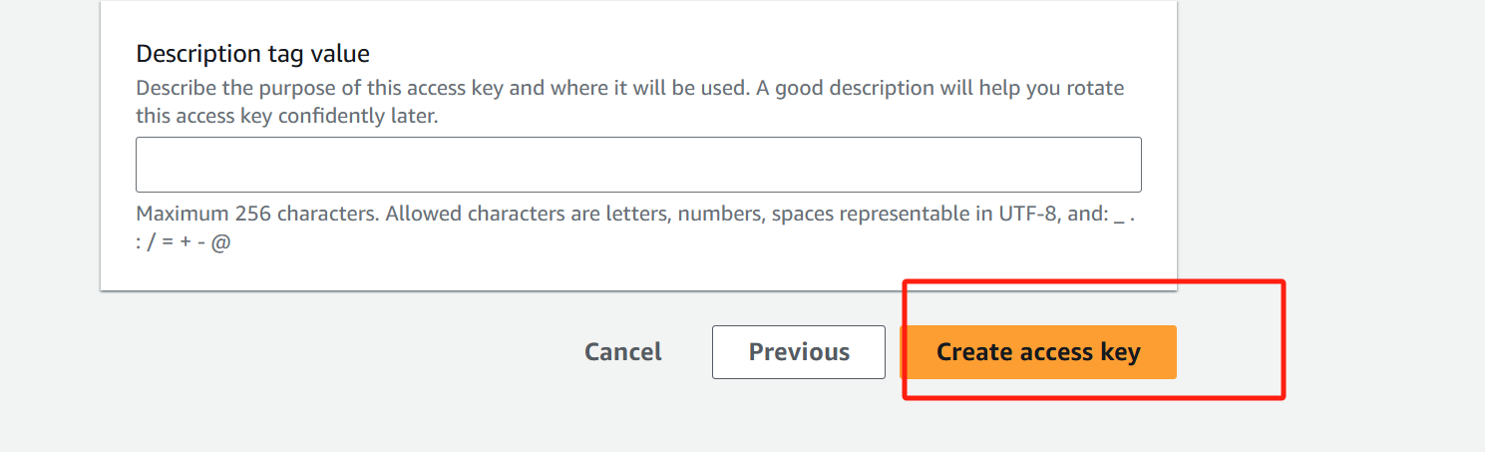

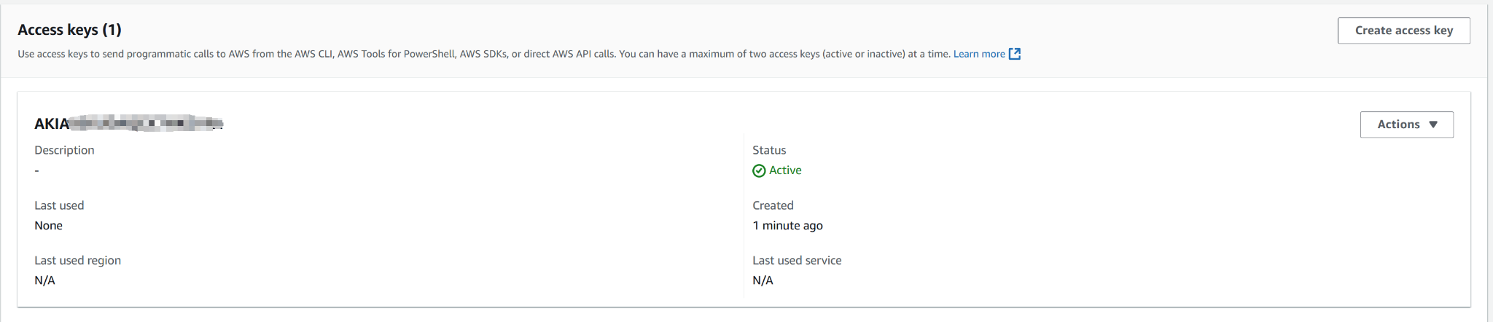

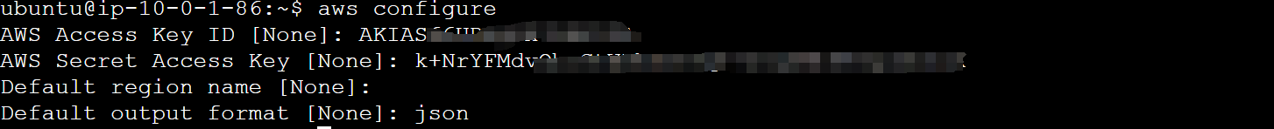

**4. Verify Access to S3**

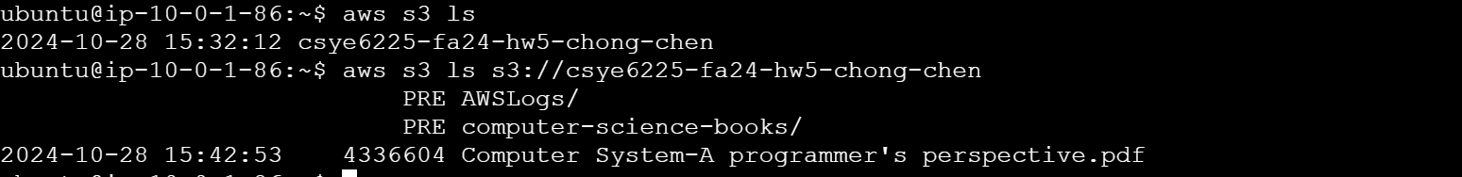

### 

### 

### 

### 

### 

### 

### 

### 

### 

### 

### 

### 

### 

### **5. Verify the Request in VPC Flow Logs or S3 Logs**

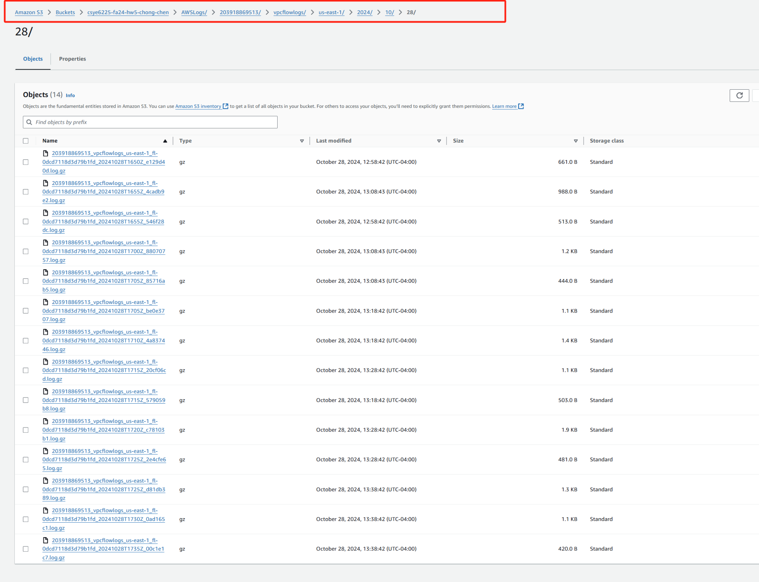

**Choose one and download**

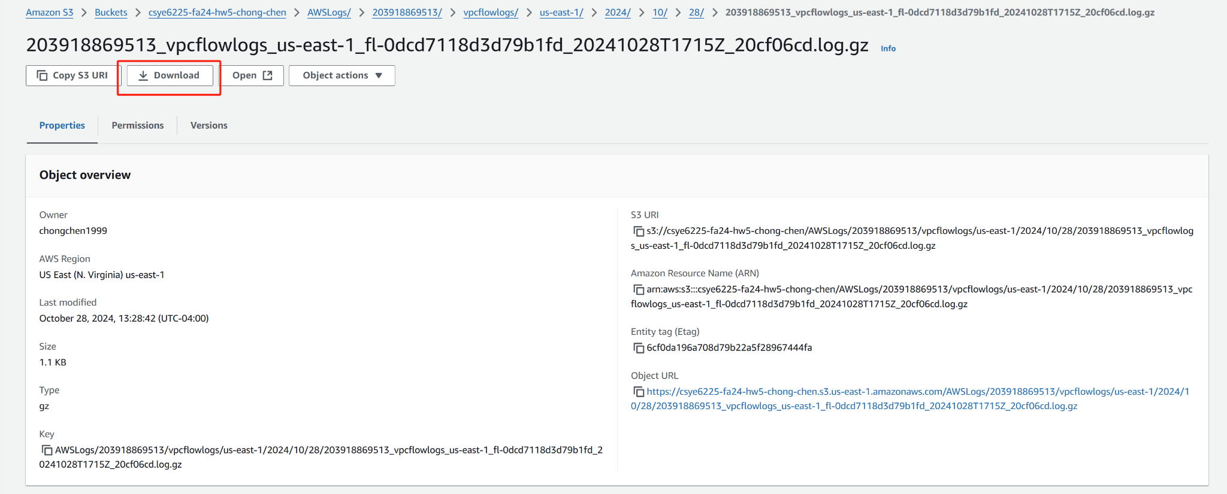

**I write a python script to create a formatted xlsx file**

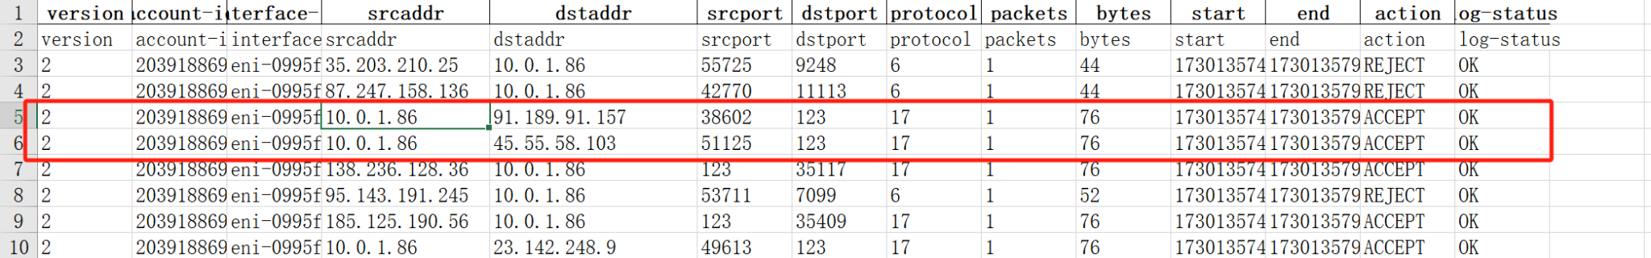

**Look for the Requester IP field, which matches the private IP of my EC2 instance**

